**CZECH UNIVERSITY OF LIFE SCIENCES PRAGUE**

**Faculty of Economics and Management**

**System Engineering and Informatics**



**Statistical Data Analysis Project**

**Data Filter ID: 8**

Prepared By

**Sadman Amir**

Submitted to

**Instructor: Ing. Tomáš Hlavsa**

# Table of Content

**Table of Content** **2**

**Introduction** **5**

Abstract 5

Methodology 6

**Chapter one** **7**

Exploratory data analysis 7

Descriptive statistics 7

Customer revenue 7

Household income 9

Customer subscription 10

Age 11

Years as a customer 12

Pie chart for gender 13

**Chapter two** **14**

Categorical data analysis 14

Customer Revenue with Household income 17

Testing 18

Conclusion 19

**Chapter three** **19**

Classical Regression Analysis 19

Pairwise correlation 20

Model building 21

Testing 22

Conclusion 24

**Chapter four** **25**

Logistic Regression 25

Exploratory data analysis 25

Conclusion 35

# List of figures

# 

# Introduction

Statistical data analysis is a process of inspecting, cleaning, transforming, and modeling data with the goal of discovering useful information, informing conclusion, and supporting decision-making. Data analysis has multiple facts and approaches, encompassing diverse techniques under a variety of names, and is used in different business, science, and social science domains.

## Abstract

In this document statistical data analysis performed for the **Customer Revenue** dataset. The document comprises four chapters. The first chapter presented exploratory data analysis of the stated variables. In the second chapter, we did categorical data analysis for selected variables. The third chapter deals with multiple linear regression to build a classical regression model that can be used to predict the revenue of individual customers of different backgrounds. The last chapter discusses logistic regression basically the binary logistic regression to examine the probability of the occurrence of our variable of interest.

## 

## 

## 

## 

## Methodology

SAS Enterprise Guide tool used to analyze the given statistical data and we follow basic procedures.

* Filtered the data with the given filter id 8
* The total number of observations of the filtered data is 2836.
* Exploratory data analysis is used to visualize our data. The descriptive statistics in this section will later be used for the purpose of undertaking other types of data analysis.
* Hypotheses for individual types of analysis are put based on exploratory data analysis.
* Model testing is done to accept or reject the hypothesis.
* Practical interpretation
* Conclusion

**Note**:

* For this statistical purpose level of significance,α= 0.05 is chosen
* Coefficient of correlation r = 0.8 chosen as a threshold value to examine the problem of multicollinearity.
* We ignored the gender category “U” when analyzing variable gender because the subject categories are male and female. The number of observations after removing the U category is N=2742.

# 

# 

# 

# 

# 

# Chapter one

## Exploratory data analysis

For this chapter, exploratory data analysis was performed to analyze the given data sets and summarize their main characteristics. Descriptive for the quantitative variables customer revenue, household income, years as a customer, customer subscription and age.Pie chart for the qualitative variable gender.

**List of variables**

* Customer revenue
* Gender
* Household income
* Years as a customer
* Customer subscription count
* Age
* Gender

## Descriptive statistics

### Customer revenue

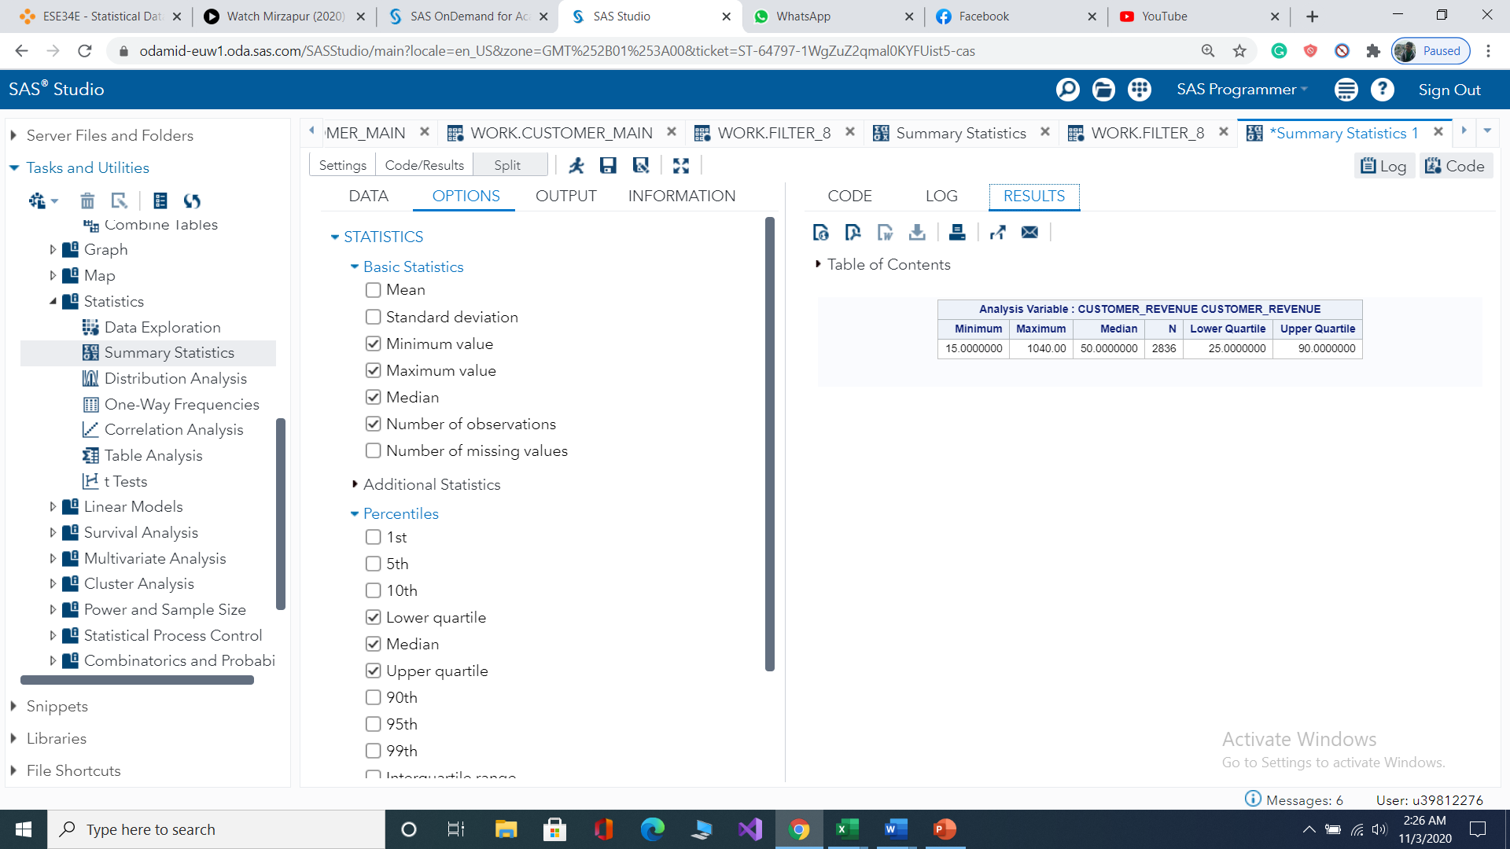

*Figure Descriptive statistics*

**Practical Interpretation**

* From the observed population, the maximum amount for customer revenue is 1040 dollars.
* From the observed population, the minimum amount for customer revenue is 15 dollars.
* The 25 percent of the observed population has a customer revenue of below 25 dollars.
* The 50 percent of the observed population has a customer revenue of below 50 dollars.
* The 75 percent of the observed population has a customer revenue of below 90 dollars.
* The interquartile range lies between 90 and 25 dollars and the values that are1.5*IQR below and above Q1 and Q3 respectively are considered outliers. Therefore, values above 200 dollars are outliers.

*Figure customer revenue box plot*

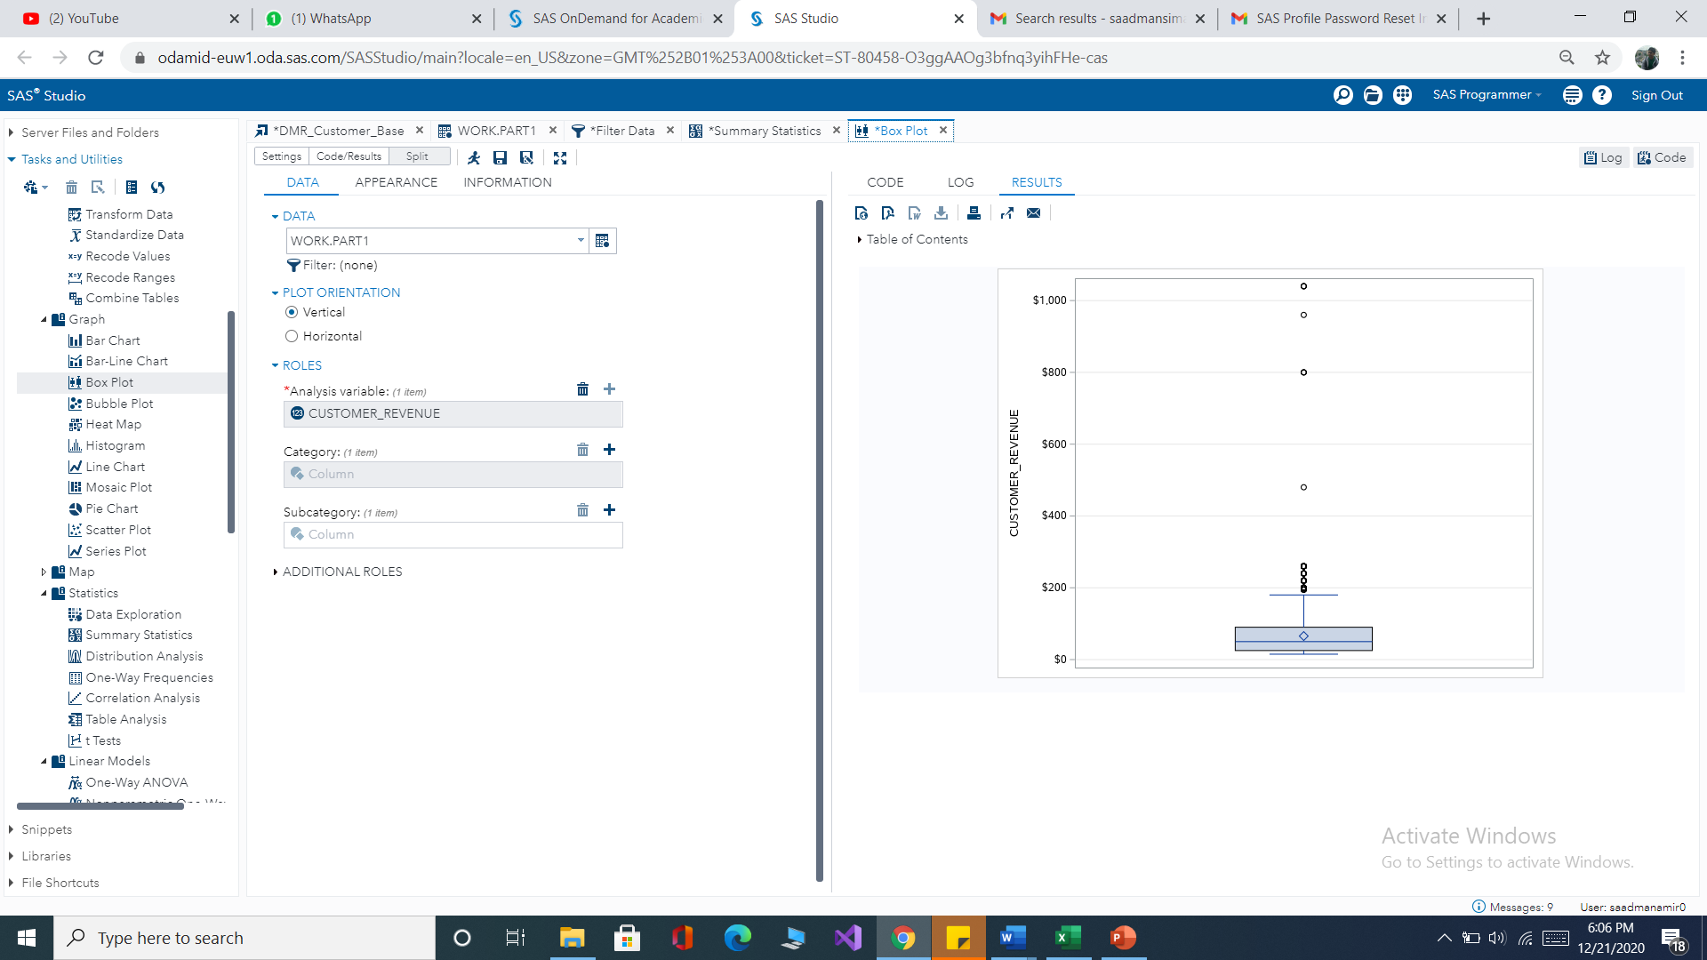

### Household income

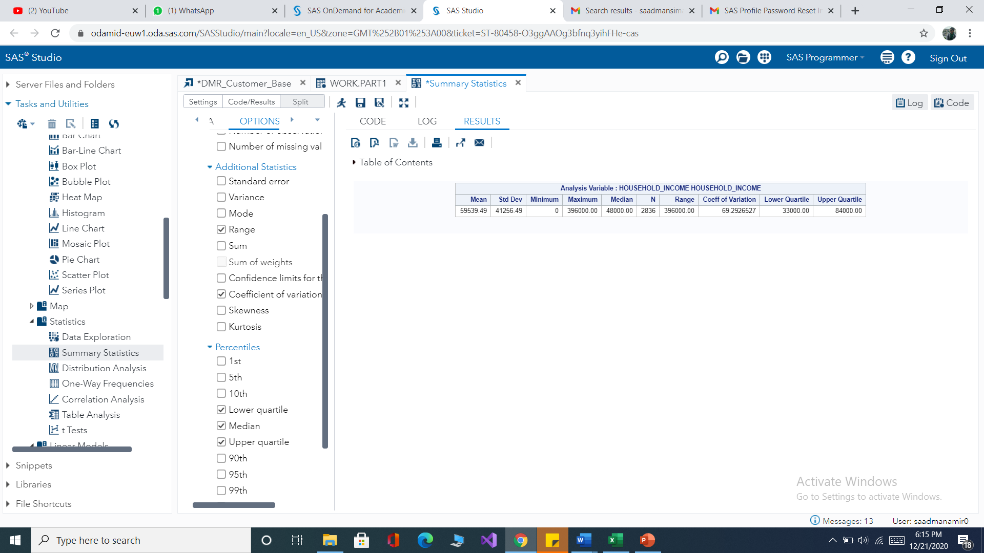

Figure Descriptive analysis of household income

* From the observed population, the maximum amount for Household income is 396000 dollars
* From the observed population, the minimum amount for Household income is 0 dollars (no income)
* For the observed population, the average amount for Household income is 59539.49 dollars.
* The 25 percent of the observed population has a Household income of below 33000 dollars.
* The 50 percent of the observed population has a Household income of below 48000 dollars.
* The 75 percent of the observed population has a Household income of below 84000 dollars.
* The interquartile range lies between 84000 and 33000 dollars and the values that are1.5*IQR below and above Q1 and Q3 respectively are considered outliers. Therefore, values above 160,500 dollars are outliers.
* The coefficient of variation for the variable was found to be 69.3% which is higher than 50% indicating large variability.

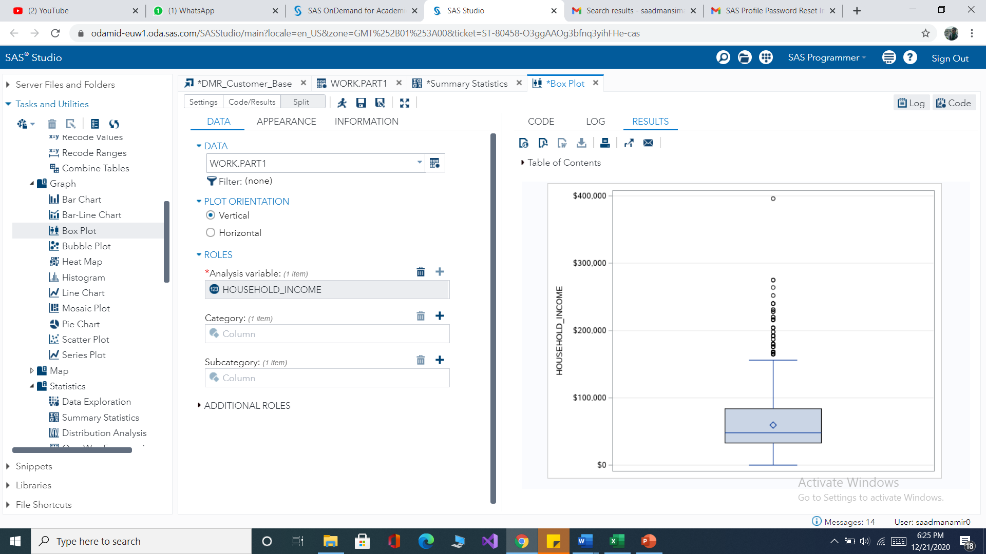

*Figure household income boxplot*

### Customer subscription

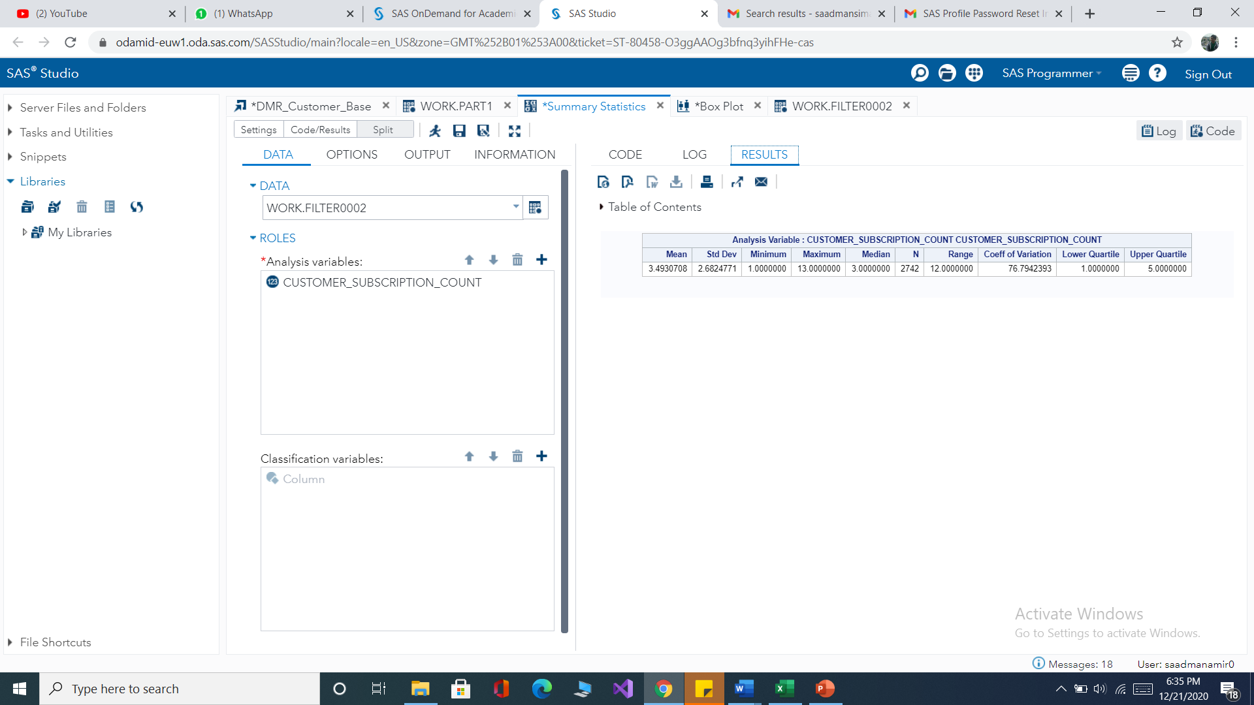

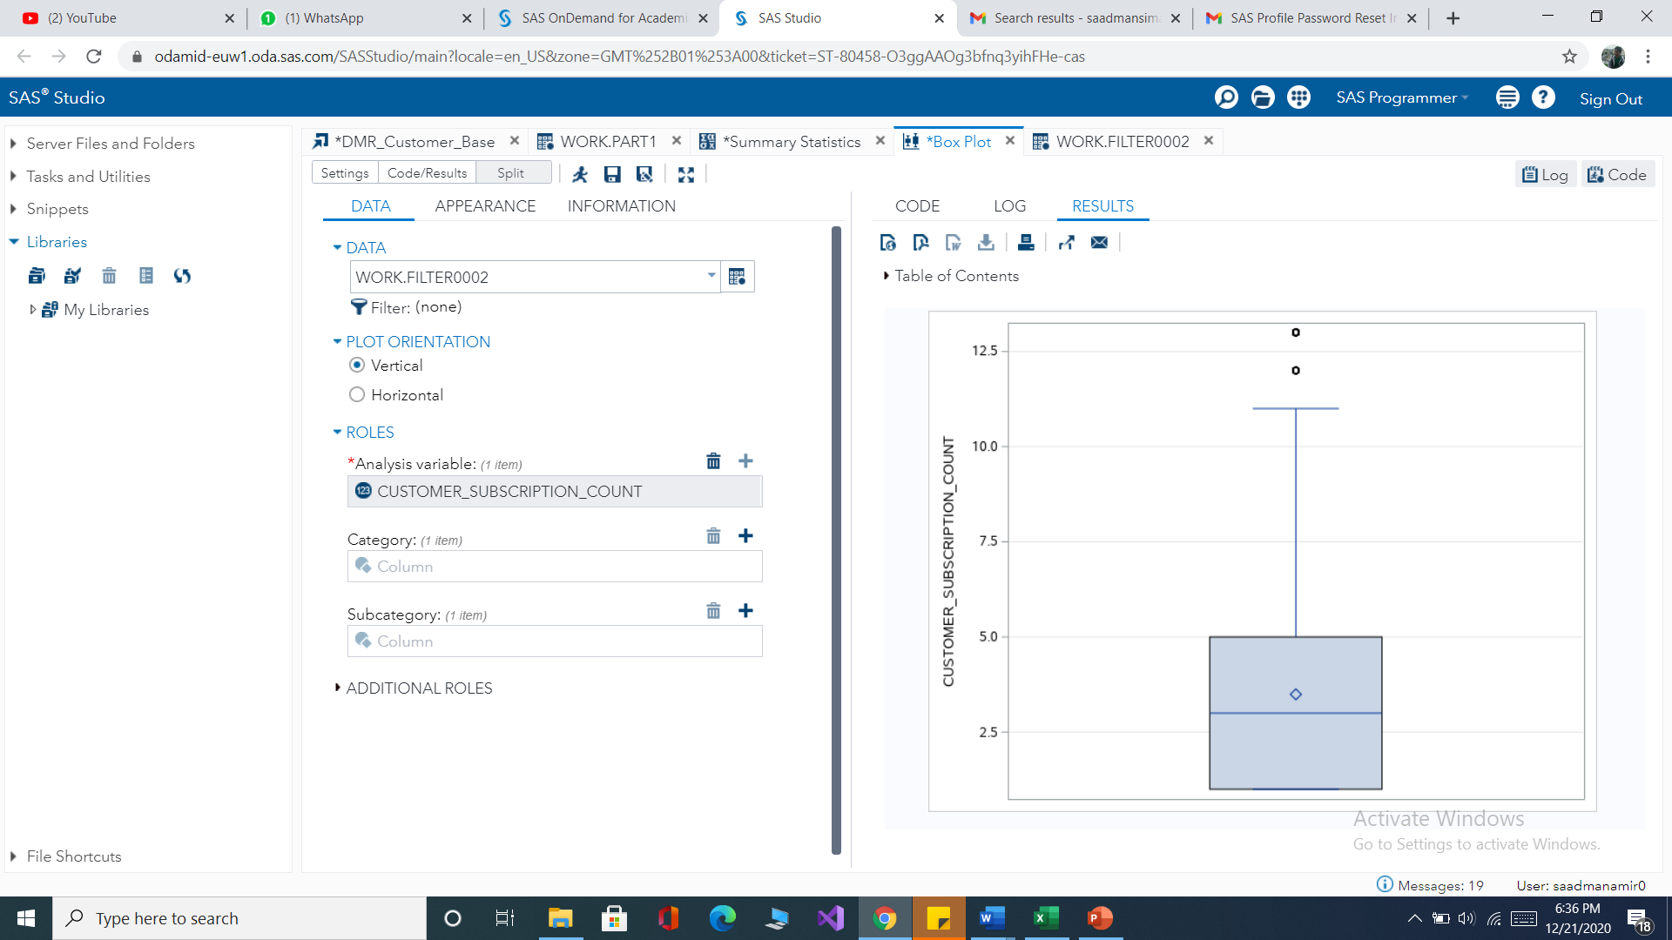

*Figure exploratory data analysis for customer subscription*

**Practical Interpretation**

* From the observed population, the maximum number of customer subscriptions is 13.
* From the observed population, the minimum number of customer subscriptions is 1.
* For the observed population, the average number of customer subscriptions is 3.
* The 25 percent of the observed population has a customer subscription below 1.
* The 50 percent of the observed population has a customer subscription below 3.
* The 75 percent of the observed population has a customer subscription below 5.
* The interquartile range lies between 5 and 1 and the values that are1.5*IQR above Q1 and Q3 respectively are considered outliers. Therefore, values above 11.5 are outliers.
* The coefficient of variation for the variable was found to be 76.79 % which is higher than 50% indicating large variability.

### Age

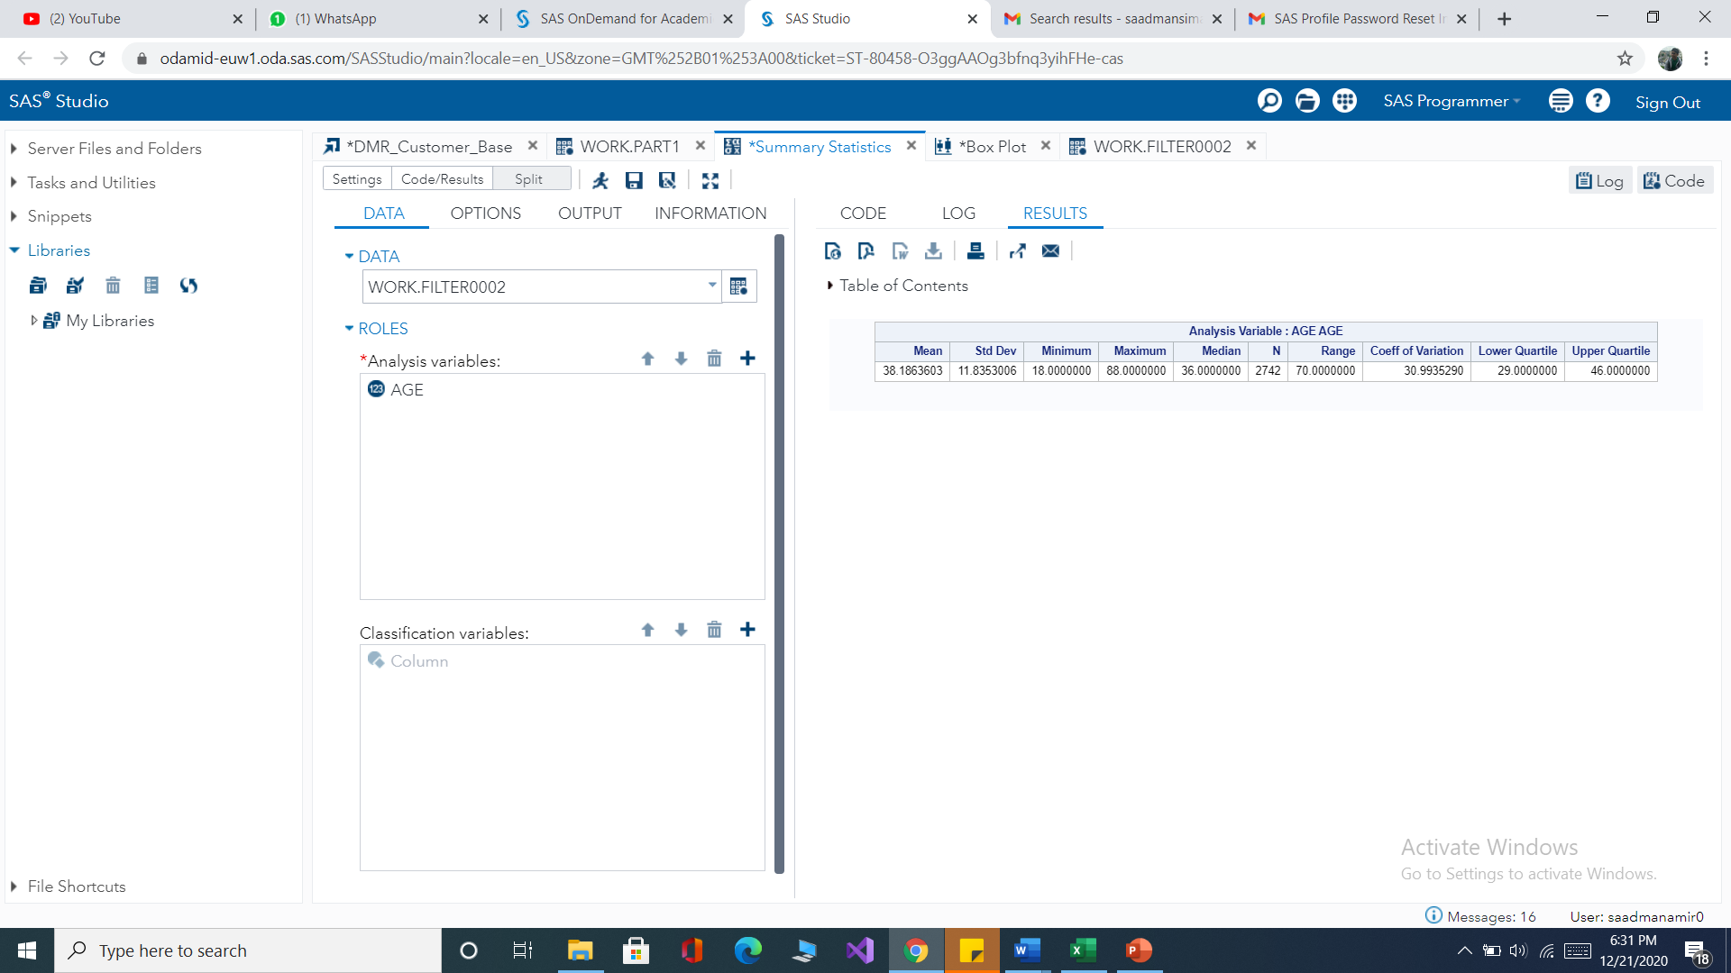

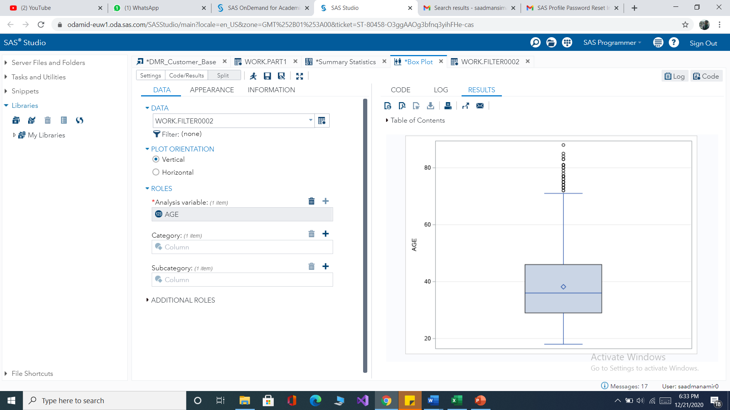

*Figure exploratory data analysis for age*

* From the observed population, the maximum age is 88 years old.
* From the observed population, the minimum age is 18 years old.
* For the observed population, the average age is 38 years old.
* The 25 percent of the observed population is below 29 years of age.
* The 50 percent of the observed population is below 36 years of age.
* The 75 percent of the observed population is below 46 years of age.
* The interquartile range lies between 46 and 29 and the values that are1.5*IQR below and above Q1 and Q3 respectively are considered outliers. Therefore, values above 75 years old are outliers.
* The coefficient of variation for the variable was found to be 31 % which is lower than 50% indicating lower variability.

### Years as a customer

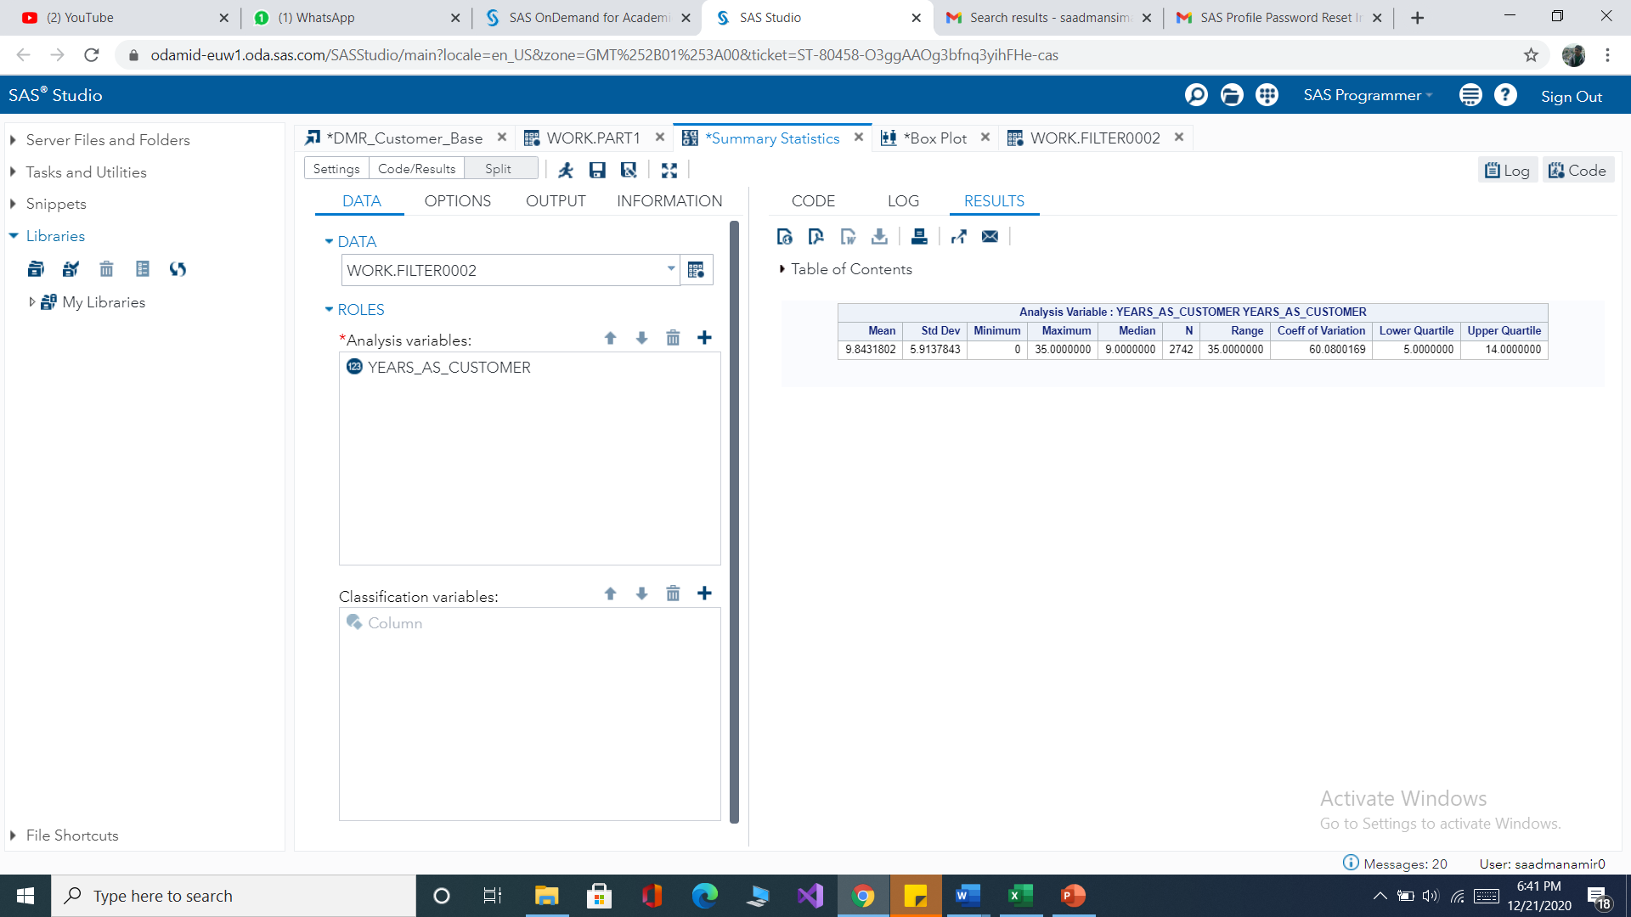

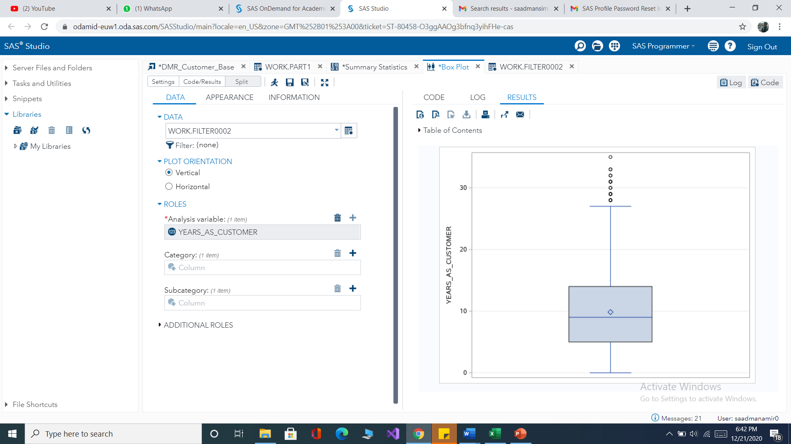

*Figure exploratory data analysis for years as a customer*

* From the observed population, the maximum year as a customer is 35 years.
* From the observed population, the minimum year as a customer is 0 years.
* For the observed population, the average year as a customer is 9 years and 8 months.
* The 25 percent of the observed population is below 5 years.
* The 50 percent of the observed population is below 9 years.
* The 75 percent of the observed population is below 14 years.
* The interquartile range lies between 14 and 5 and the values that are1.5*IQR below and above Q1 and Q3 respectively are considered outliers. Therefore, values above 26 are outliers.
* The coefficient of variation for the variable was found to be 60 % which is higher than 50% indicating higher variability.

### Pie chart for gender

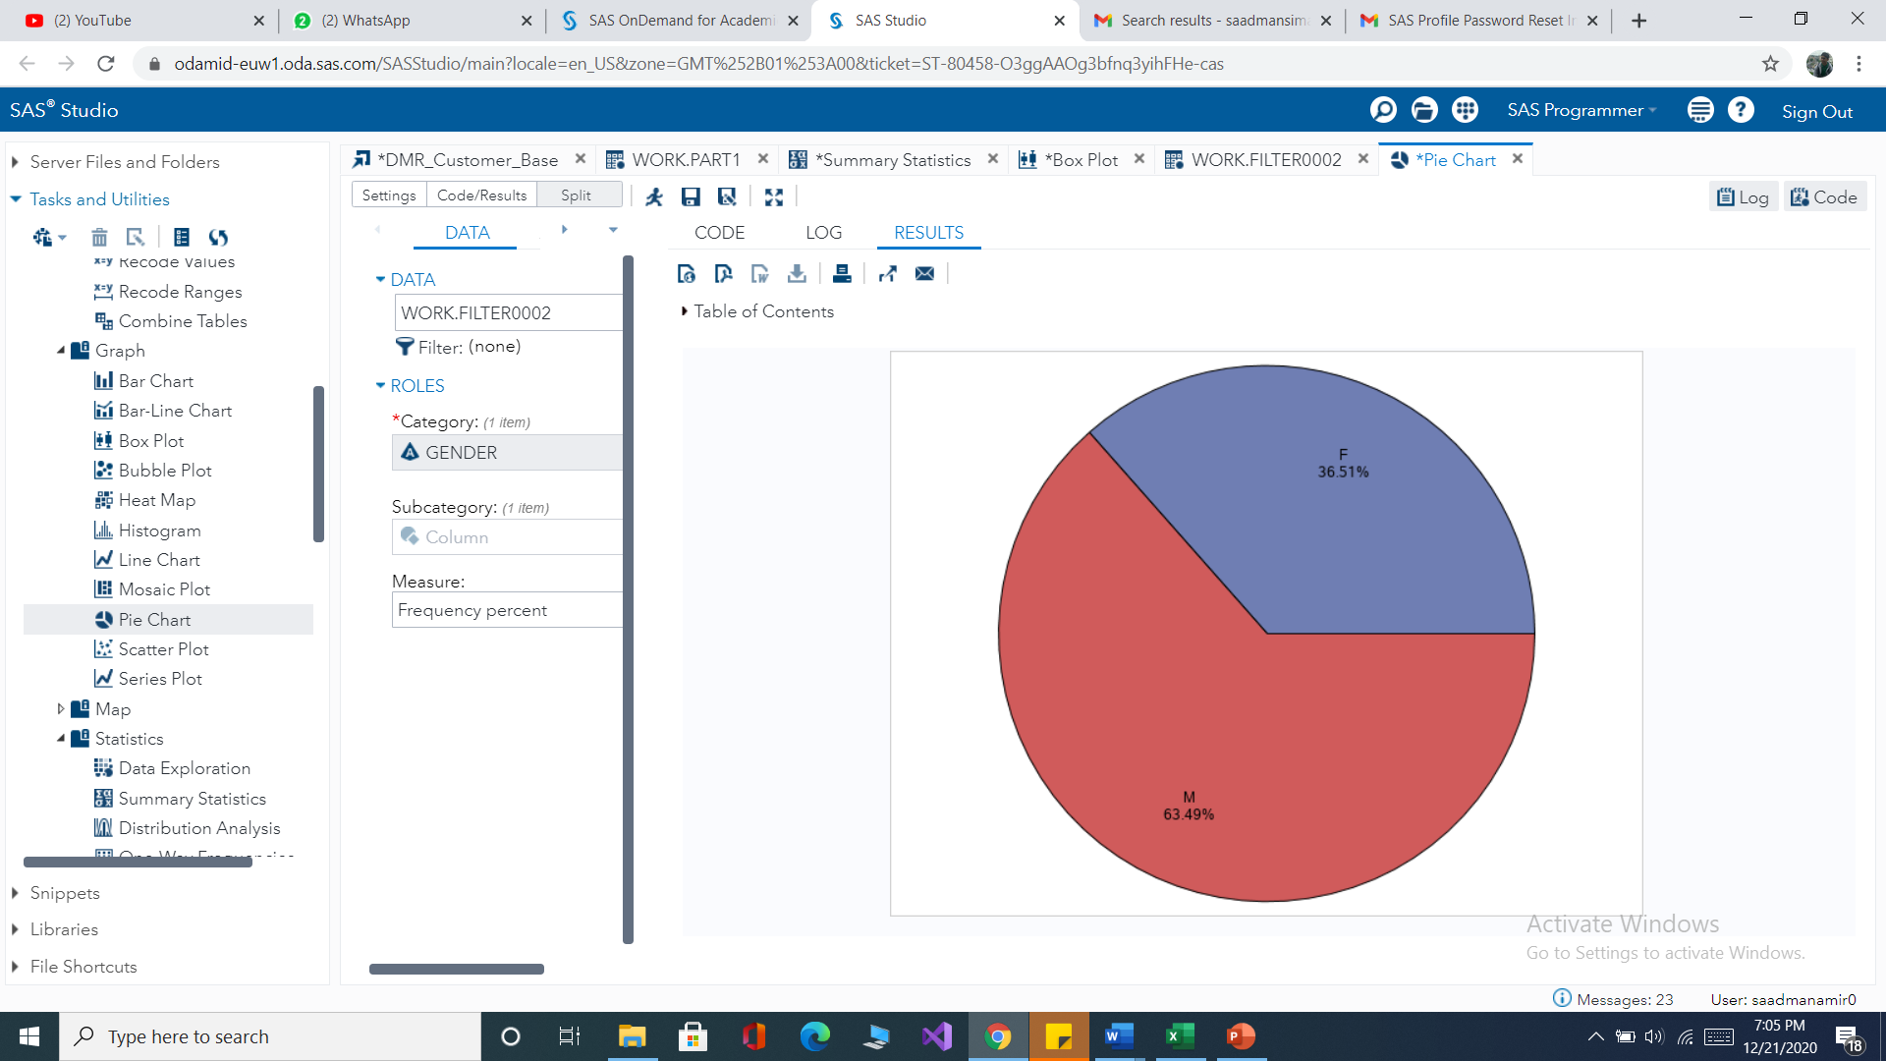

*Figure pie chart for gender*

* 36.51 % of the observed population are females and the rest 63.49 percent are male.

## 

# Chapter two

## Categorical data analysis

Using Categorical data analysis, we analyze data that fall into different categories. Customer revenue is the dependent variable, and we examined its relationship with the categorical data gender and household income.

**Step one**

Categorizing variables customer revenue and household income using quartile information from the descriptive statistics.

|  |  |
| --- | --- |
| **Customer revenue** | |
| Range | Code |
| >=90 | 1 |
| <90 | 0 |

|  |  |
| --- | --- |
| **Household income** | |
| Range | Code |
| <33000 | 1 |
| >=33001 and < 48000 | 2 |
| >=48001 and<84000 | 3 |
| >=84000 | 4 |

*Table customer revenue and household income group*

**Step two**

After categorizing the variables, we examined the relationship of dependent variable customer revenue with gender and household income separately.

**Customer revenue with gender**

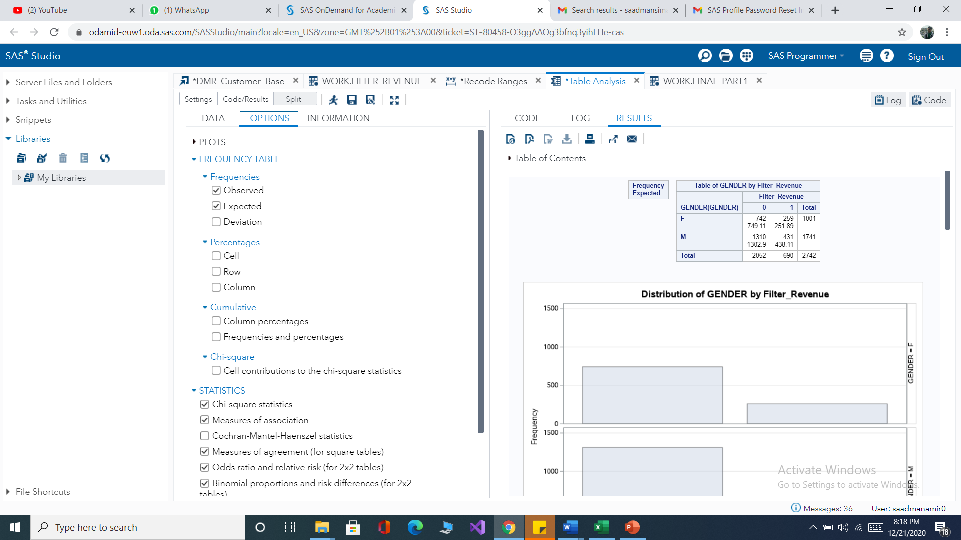

*Figure Categorical data analysis*

**Practical Interpretation**

**Contingency table Interpretations**

1 categorical ratio is 25% and 0 categorical ratio is 75 %. So observed result is 2742 customers. From that result 690 customers whom income revenue between 90$ to 1040$ and rest 2052 customers have 15$ to 89$ income revenue.

**Chances and risks interpretation**

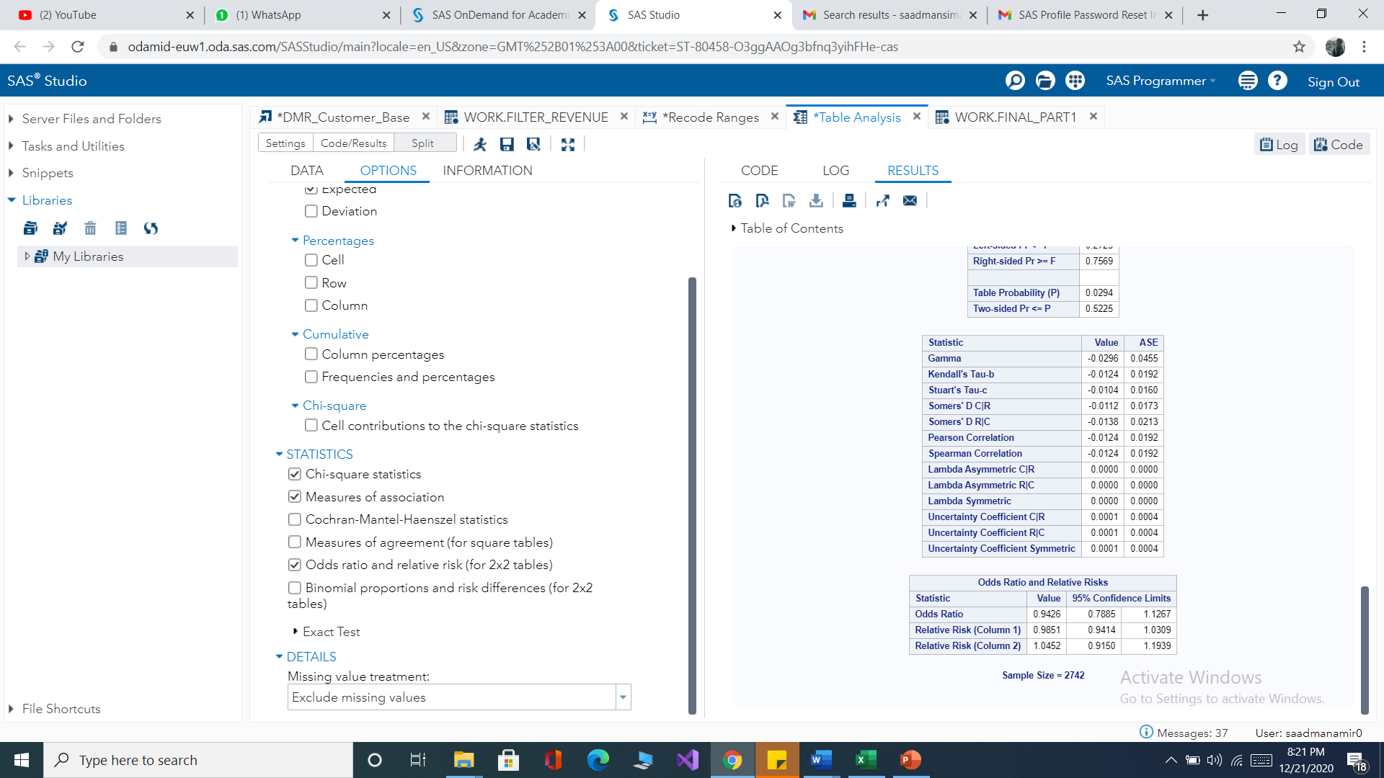

*Figure chance and risk interpretation*

RR1 < a probability that female is in 'rest' category of customer revenue is less likely expected than male is in 'rest' category of customer revenue. Chance to be in 'rest' category is decreasing for females.

• RR2 >1 probability that female is in 'top 25%' of category of customer revenue is more likely expected than male is in 'top 25%' category of customer revenue. Chance to be in 'top 25%' category is increasing for females.

. • Odds ratio (OR) (0.98521/1.0452)= 0.9426 chance is almost same for females and males to be in rest category of customer revenue.

### Customer Revenue with Household income

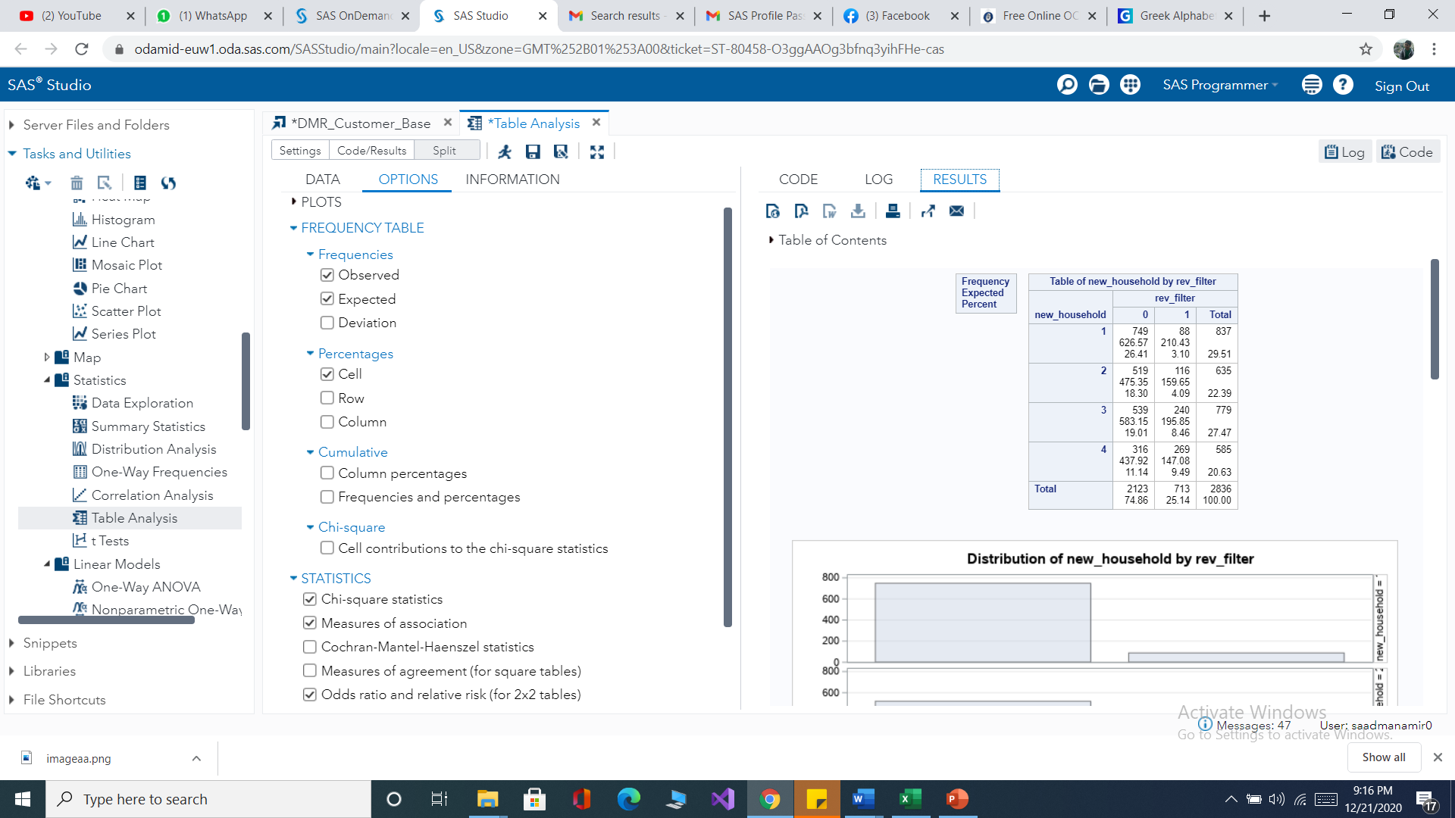

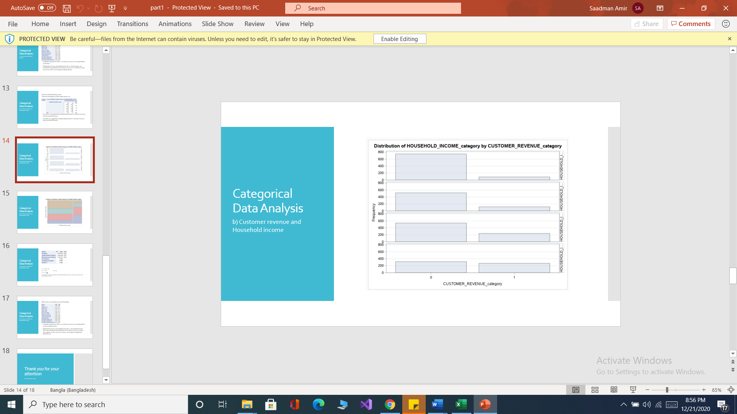

*Figure contingency table customer revenue with household income*

**Contingency table interpretation**

* 26.41% of the total population have below 33000 dollars of household income with customer revenue of below 100 dollars
* 3.10% of the total population have below 33000 dollars of household income with customer revenue of above 100 dollars
* 18.30% of the total population has a household income of below 48000 dollars and above 33000 dollars and have a customer revenue of below 100 dollars
* 4.09% of the total population has a household income of below 48000 dollars and above 33000 dollars and have a customer revenue of above 100 dollars
* 19.01% of the total population has a household income of below 84000 dollars and above 48000 dollars and have a customer revenue of above 100 dollars
* 8.46% of the total population has a household income of below 84000 dollars and above 48000 dollars and have a customer revenue of above 100 dollars
* 11.14% of the total population has a household income of below 396000 dollars and above 84000 dollars and have a customer revenue of above 100 dollars
* 9.49% of the total population has a household income of below396000 dollars and above 84000 dollars and have a customer revenue of above 100 dollars

## Testing

Testing the statistical significance of variables to examine whether gender and household income are significant indicators of the value of customer revenue using the proper test method that is the chi-square test.

**Customer Revenue with Gender**

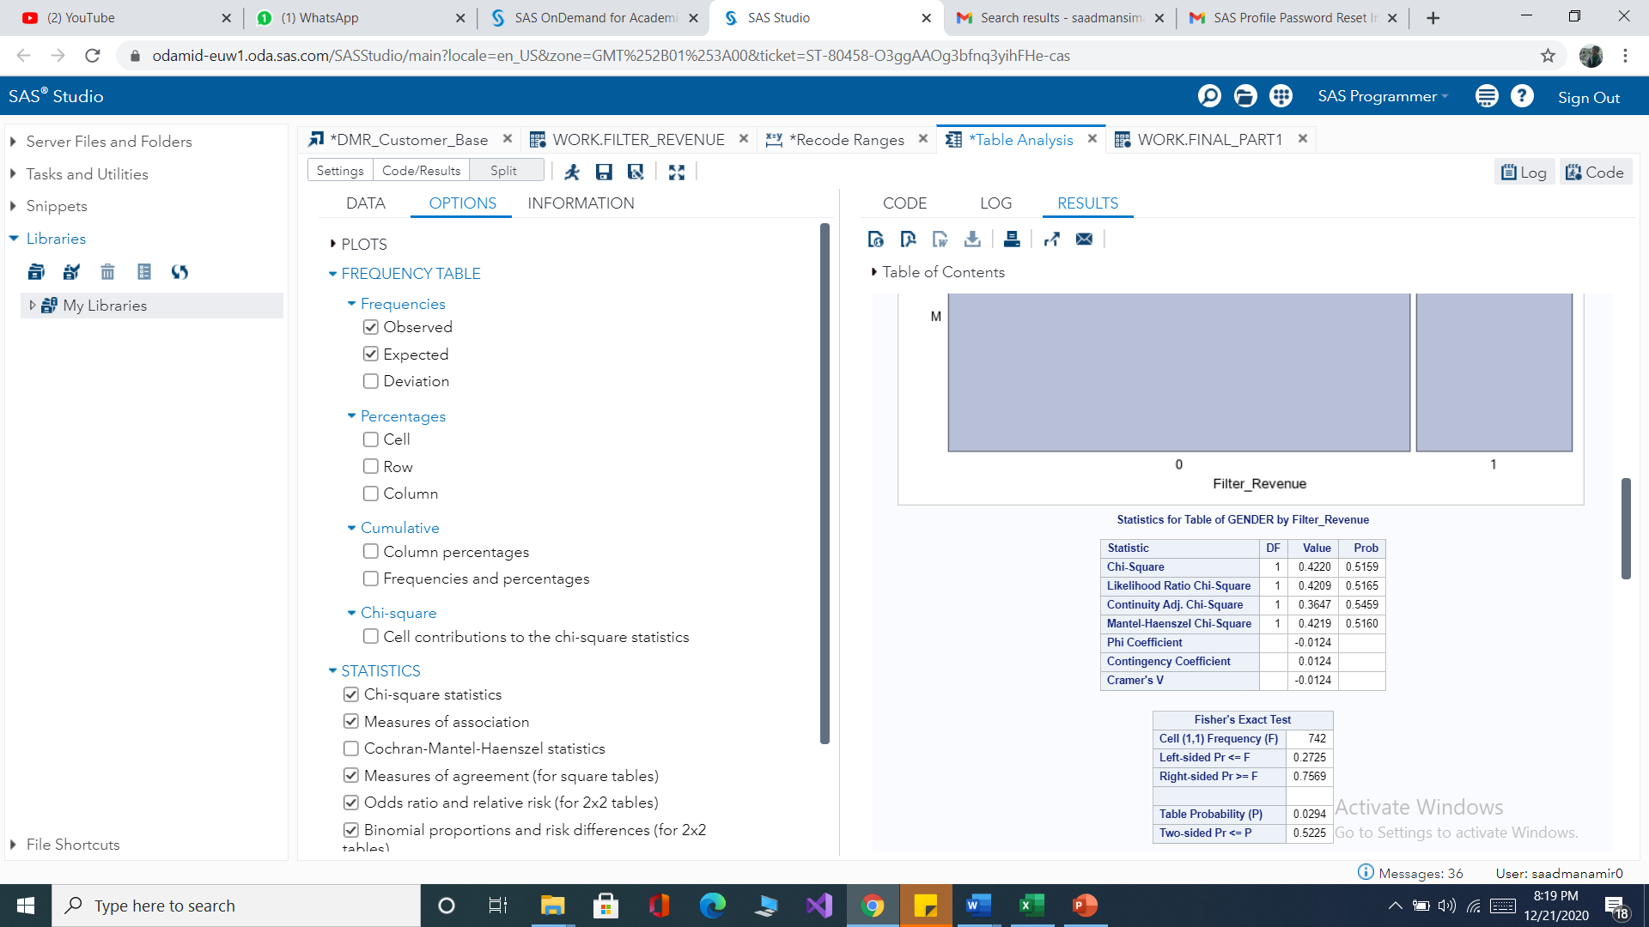

*Figure Chi-square test for customer revenue with gender*

**Hypothesis**

* Ho= There is no relationship between gender and customer revenue.
* H1= There is a relationship between gender and customer revenue

χ2=0.4220

p=0.5159

α=0.05

P-value=0.52>α, therefore we fail to reject Ho

# Pre-measures(Goodman Kruskal Lambda)

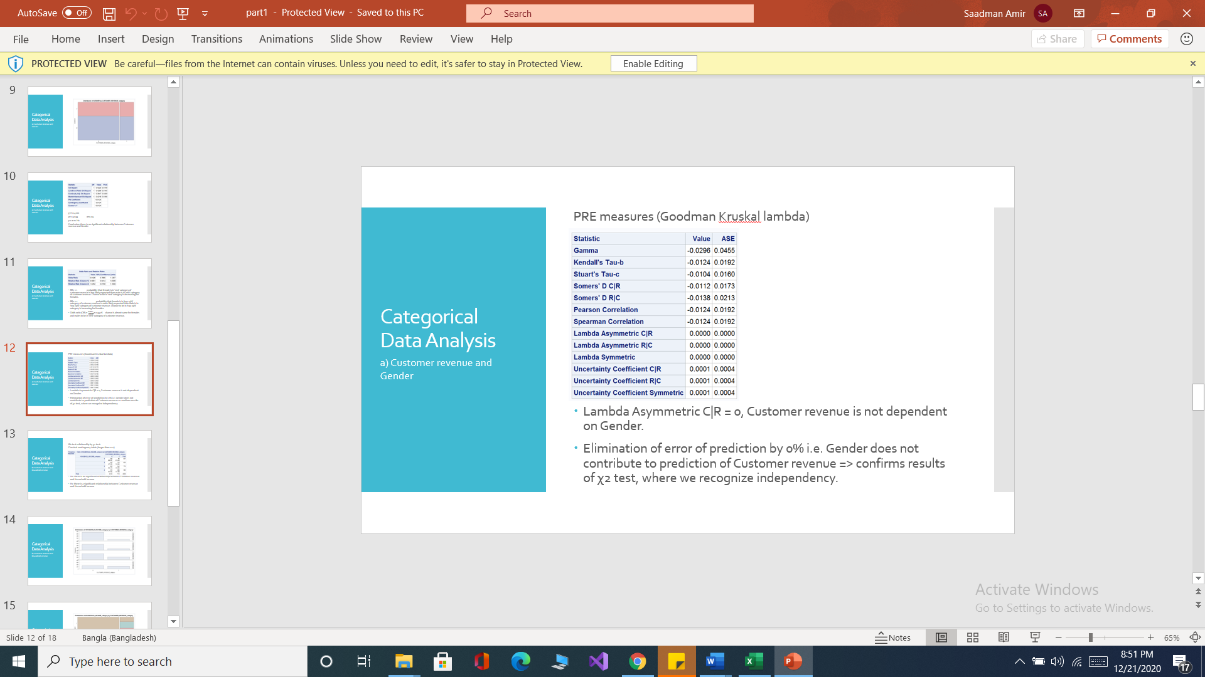

**Customer Revenue with Household income**

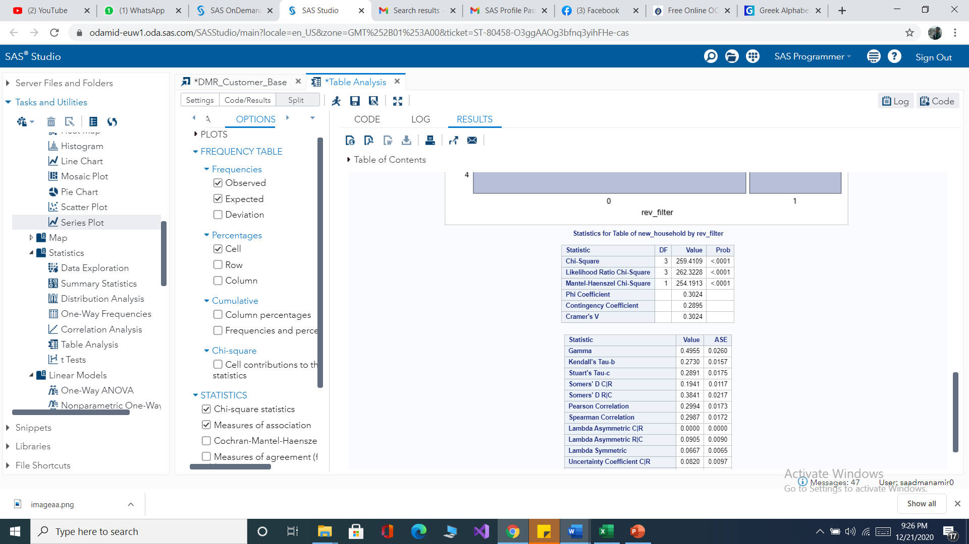

*Figure Chi-square test for customer revenue with household income*

**Hypothesis**

* Ho= there is no relationship between Household income and customer revenue.
* H1= there is a relationship between household income and customer revenue

P-value<0.001 < α, therefore we reject the null hypothesis.

# Pre-measures(Goodman Kruskal Lambda)

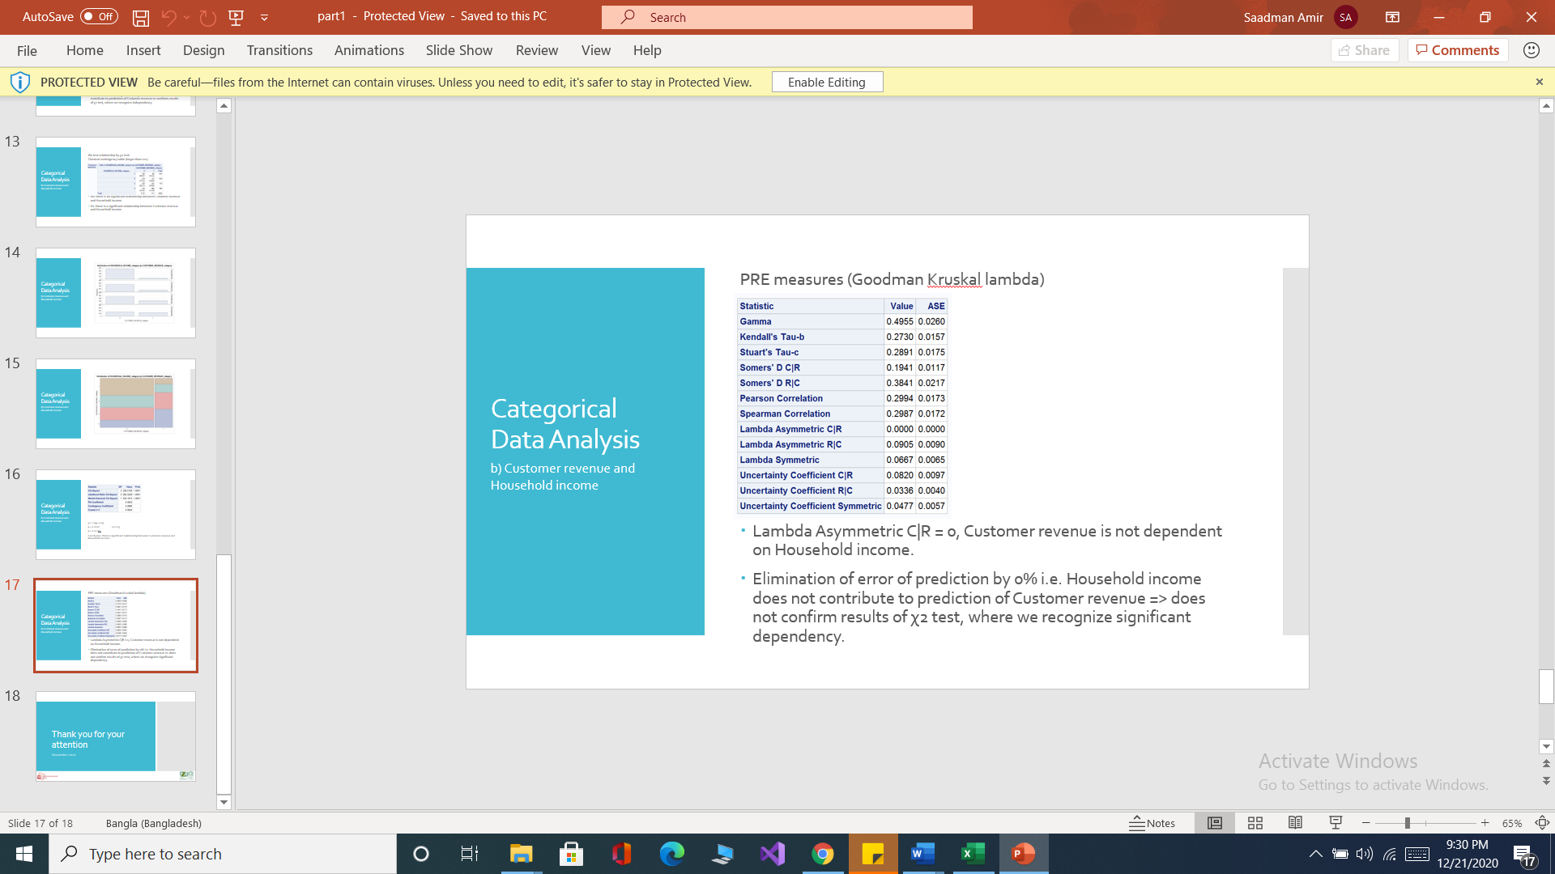

## Conclusion

* The gender of the customer is not a significant indicator of the amount of their revenue being below or above 100 dollars.
* The amount of household income is a significant indicator if their revenue is above and below 100 dollars.
* As household income increases the customer revenue also increases.

# Chapter three

## Classical Regression Analysis

Linear regression is a linear approach to model the relationship between a dependent variable and one or more explanatory variables. In this chapter Linear regression is performed to build a model that can predict the value of the customer revenue based upon customer information such as Age and Household income.

For this chapter, we analyzed the following List of variables.

* Customer revenue
* Age
* Household income
* Years as customer
* Customer subscription count

dependent variable → customer revenue

predictors → Age, Household income, Years as customer, Customer subscription count.

y→ Customer revenue

x1→ age

x2→ Household Income

x3→ years as a customer

x4→ customer subscription count

## Pairwise correlation

**examine correlation using the correlation matrix**

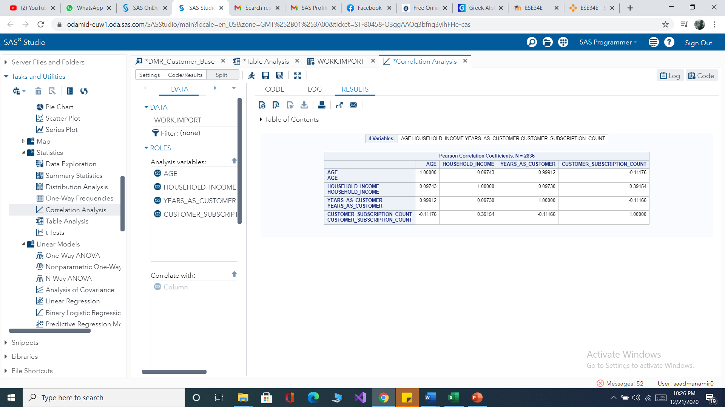

*Figure correlation coefficient*

*r <-1,1>*

*rx1x2=0.09743*

*rx1x3=0.99912*

*rx1x4= -0.11176*

*rx2x3=0.09730*

*rx2x4=0.39154*

As we can see in the above correlation matrix the coefficient of correlation between the explanatory variables x1(Age) and x3(years as a customer) is 0.99 which is greater than 0.8 this implies the relationship between the explanatory variables is stronger and we can conclude that there is a problem of multicollinearity.

**Solving the problem of multicollinearity**

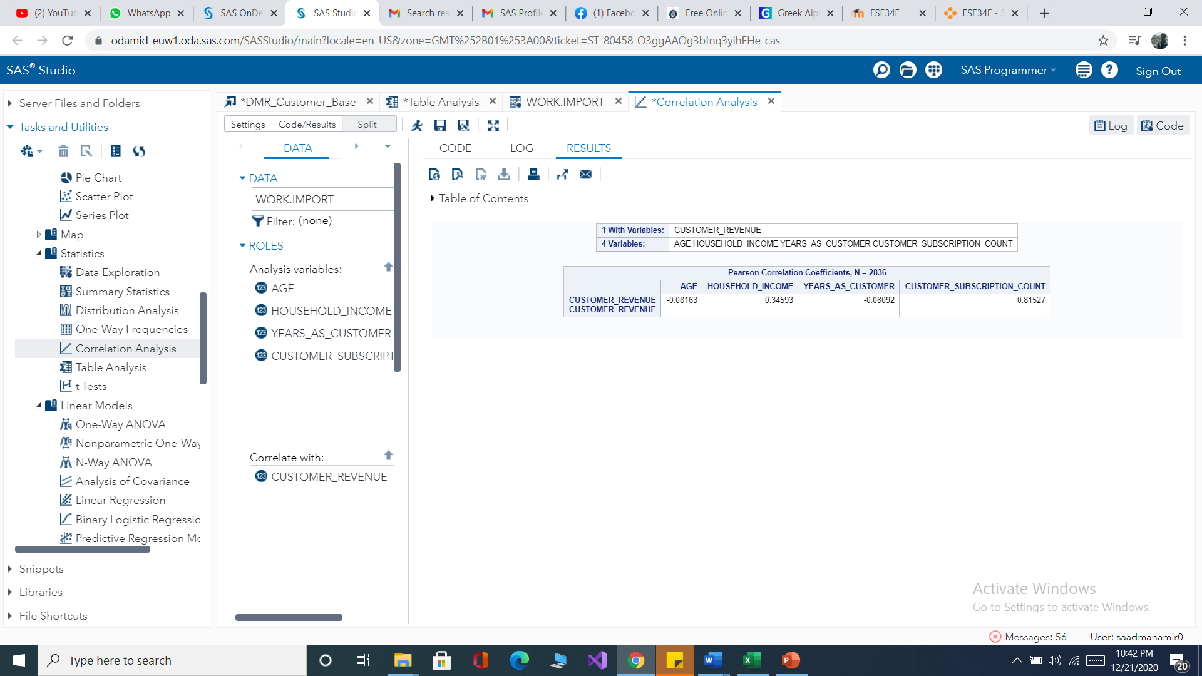

ryx1=-0.08163

ryx3=0.81527

we compared the relationship of both explanatory variables to the dependent variable y(customer revenue). Since years as a customer has a stronger relationship with the dependent variable, we chose to remove variable Age.

The new correlation matrix after taking countermeasures to solve the problem of multicollinearity is put below.

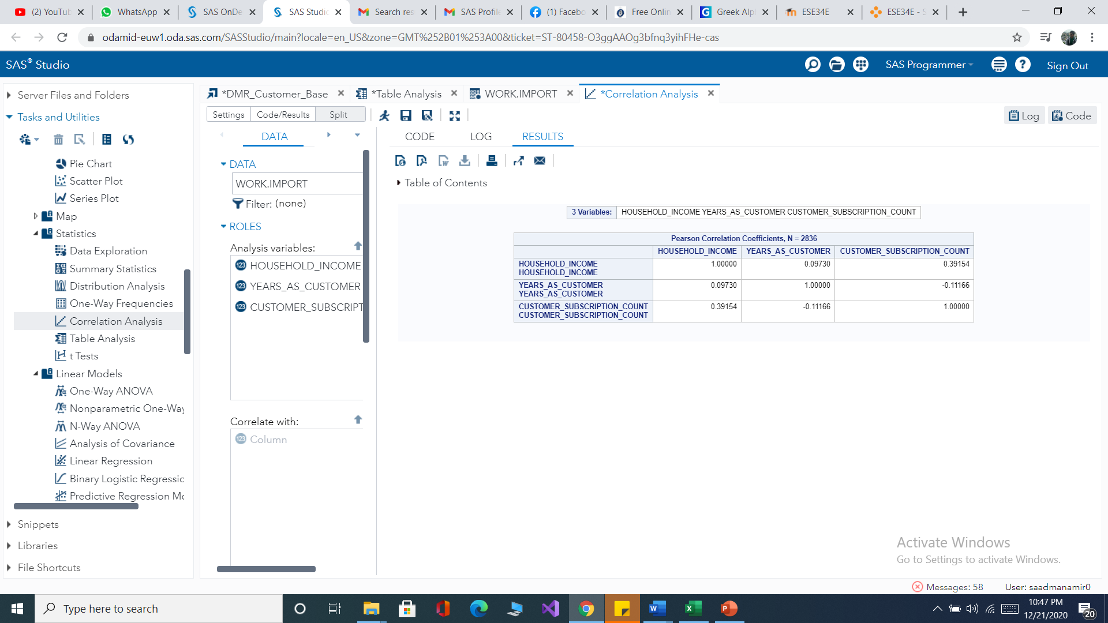

From the above figure, it can be seen that there is no problem with multicollinearity so now we can build the regression model for the prediction.

## Model building

General linear regression model, y=**a**+**ɑ1**x1+**ɑ2**x2+**ɑ3**x3

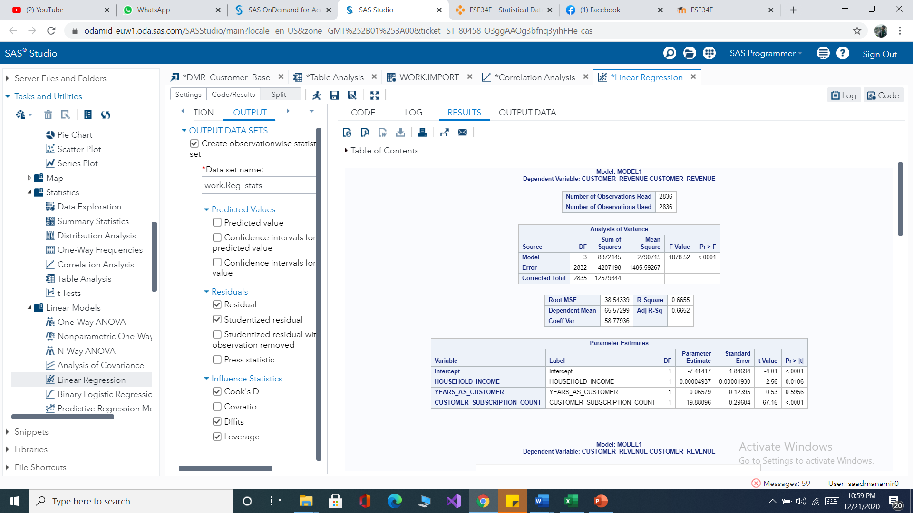

*Figure parameters from the model*

y→ Customer revenue

x1→ Household Income

x2→ years as a customer

x3→ customer subscription count

**The linear regression mode**l y= -7.41417+0.00004937x1+0.06579x2+19.88096x3

**Coefficient of determination**

Form the table the value of R2=0.66 which implies 66 percent of the variation of customer revenue is explained by the variation of household income years as a customer and customer subscription count and rest 36 percent is residuals.

## Testing

**Annova**

The significance of the whole model is examined Through the Anova test**.**



*Figure Annova Testing*

**Hypothesis**

**H0: ɑ1=ɑ2=ɑ3=ɑ4=0**

All the regression coefficients are insignificant hence the whole model is insignificant.

**H1:ɑi !=0**

At least one regression coefficient is significant hence the model is significant.

F value=1878.52 and p value= <0.0001

We reject the null hypothesis which means the model is statistically significant and one of the parameters is significant or all are significant. Now we need to test which parameter is significant using the T-test.

**T-test**

Here the significance of each parameter tested individually.



*Figure t-test of classical regression model*

**ɑ1(Household income)**

**Hypothesis**

**H0**: **ɑ**1=0

**H1 ɑ**!=0

t value=2.56 p-value=0.0106

The p-value is greater than 0.05 we reject the null hypothesis which means household income needs to be considered as a significant predictor.

**ɑ2(years as a customer)**

**Hypothesis**

**H0**: **ɑ**2=0

**H1 ɑ**!=0

t value=0.53 p-value=0.5956

The p-value is greater than 0.05 we fail to reject the null hypothesis which means years as a customer also does not need to be considered as a significant predictor.

**ɑ3(Customer subscription count)**

**Hypothesis**

**H0**: **ɑ**3=0

**H1 ɑ**!=0

t value=67.16 p-value <0.0001

the p-value is less than 0.005 we reject the null hypothesis which means customer subscription count needs to be considered as a significant predictor.

* Based on testing individually parameters we can see that means Household income & customer subscription count parameters of the model are statistically significant.

**Interpretation of the linear regression model**

y= -7.41417++0.00004937x1+19.88096x3

* Keeping the other variables constant, if household income increase by one dollar customer revenue will increase by 0.00004937 dollars.
* Keeping the other variables constant, if customer subscription count increase by one subscription customer revenue will increase by dollars.

## Conclusion

* Our model is ready for predicting the customer revenue for the general population.

# Chapter four

## Logistic Regression

Logistic regression is a statistical model that in its basic form uses a logistic function to model a binary dependent variable. It can be used to predict a variable of two outcomes. In this chapter, we make use of logistic regression to predict the value of revenue from different customers using predicting variables.

## Exploratory data analysis

step one Categorizing variable customer revenue

|  |  |
| --- | --- |
| **Customer revenue** | |
| Range | Code |
| >=90 dollar | 1 |
| <90 dollar | 0 |

step two descriptive statistics for household income, customer subscription, and age. Pie chart for gender performed according to the category of the customer revenue above and below 90 dollars.

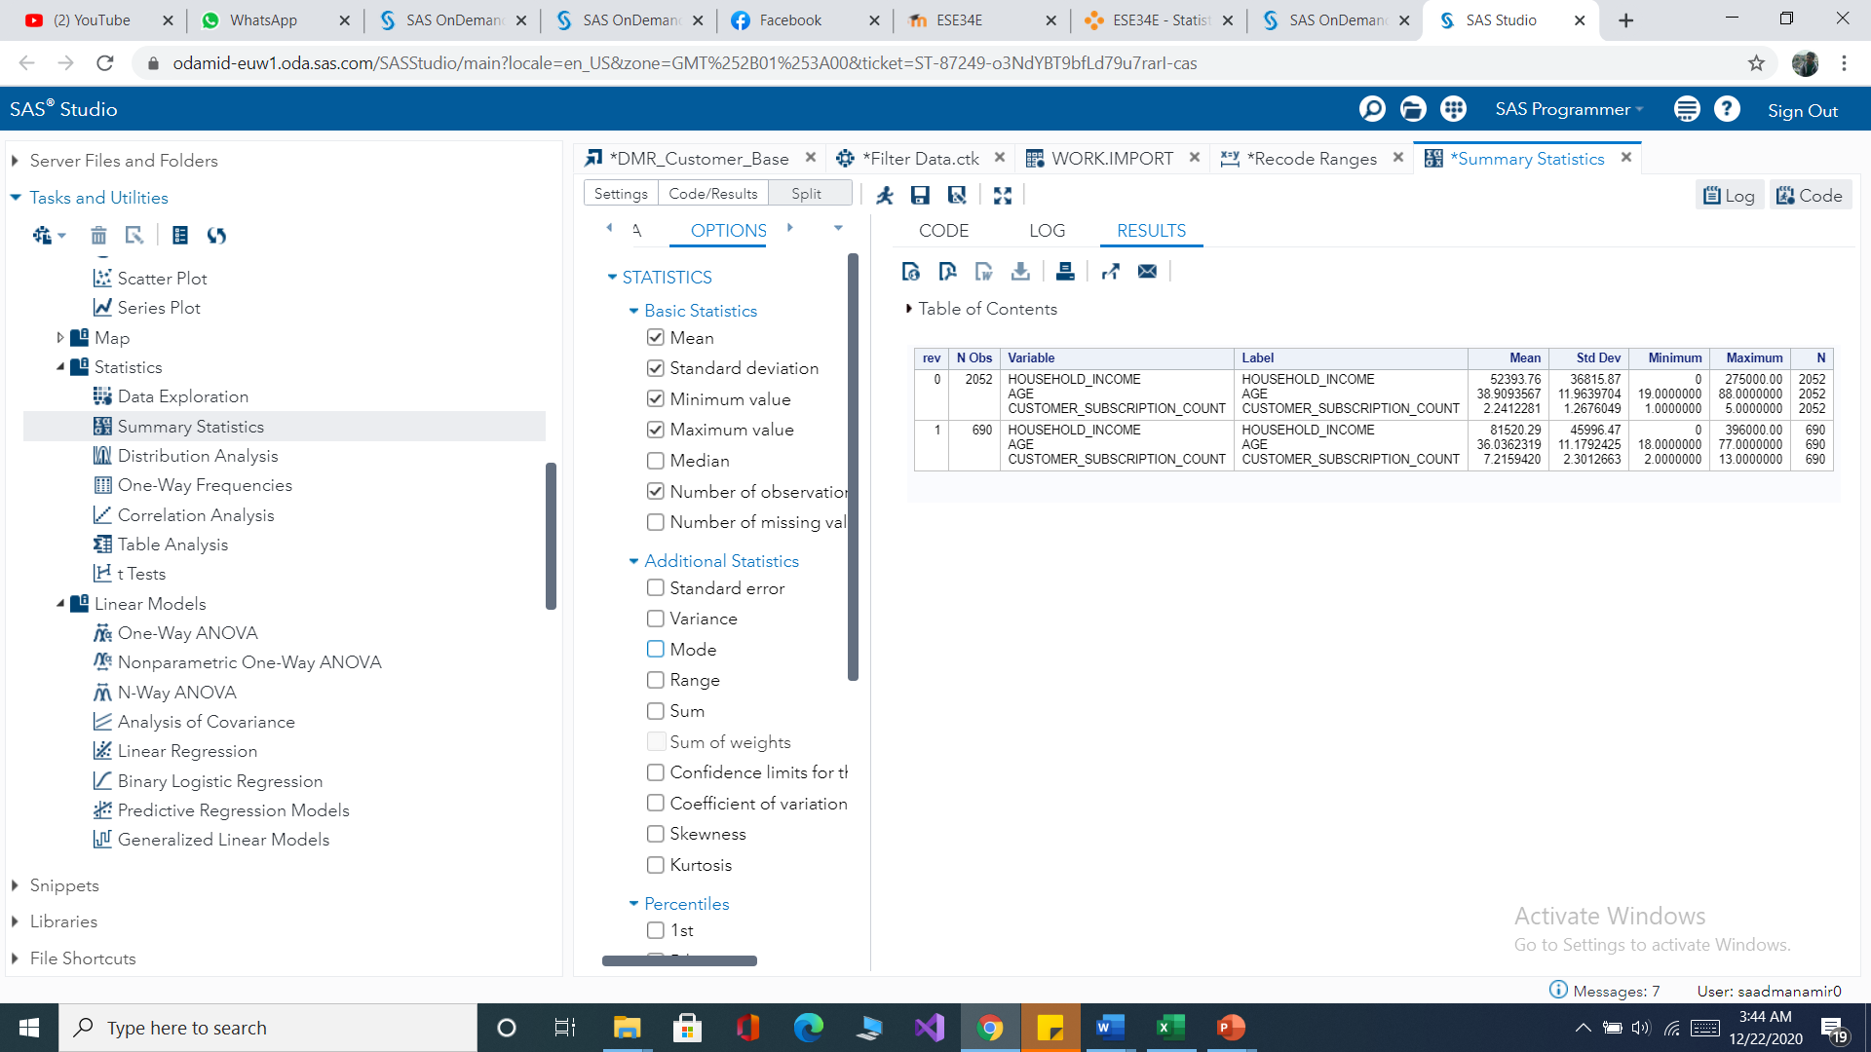

*Figure parameters from the model*

**practical Interpretation**

* Customers with higher household incomes have a customer revenue of above 90 dollars.
* Customers with higher customer subscription count have a customer revenue of above 90 dollars.
* Customers with older age have a customer revenue of below 90 dollars.

**Gender**

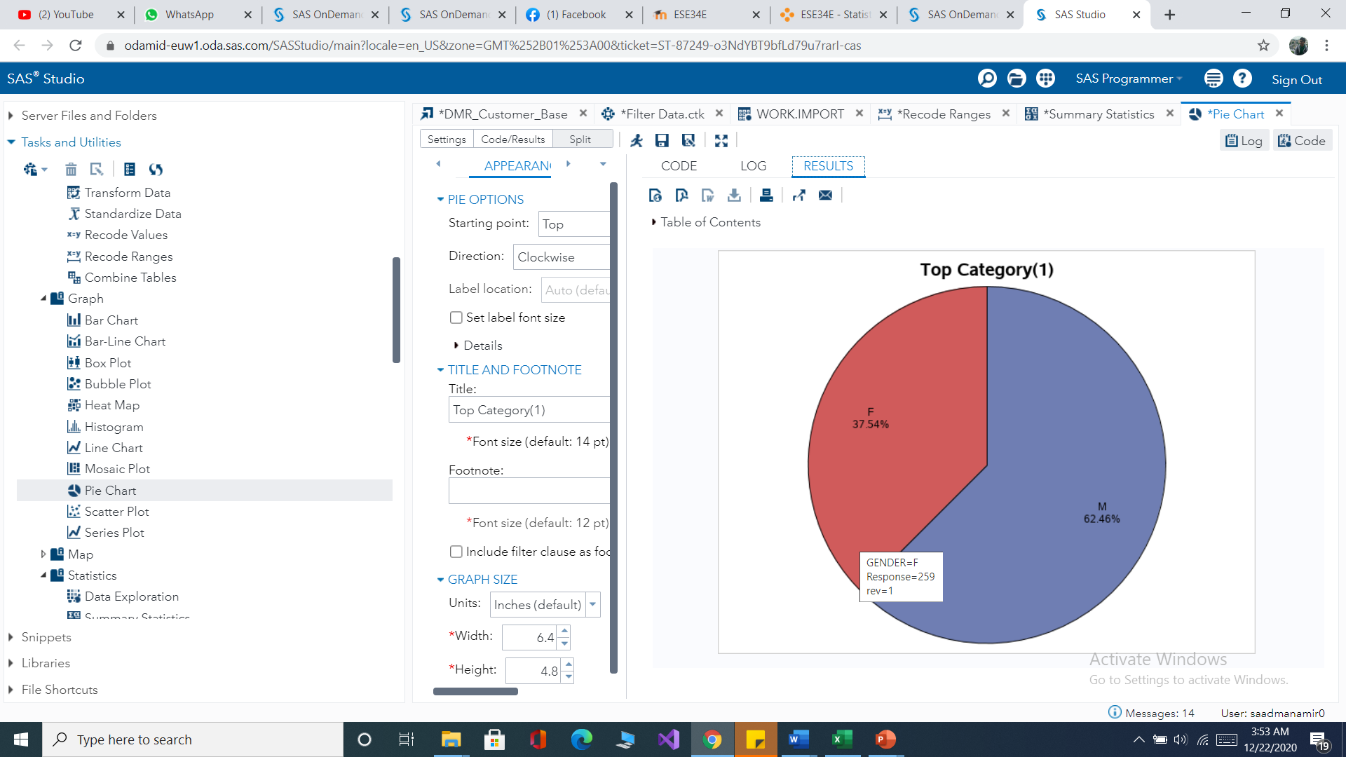

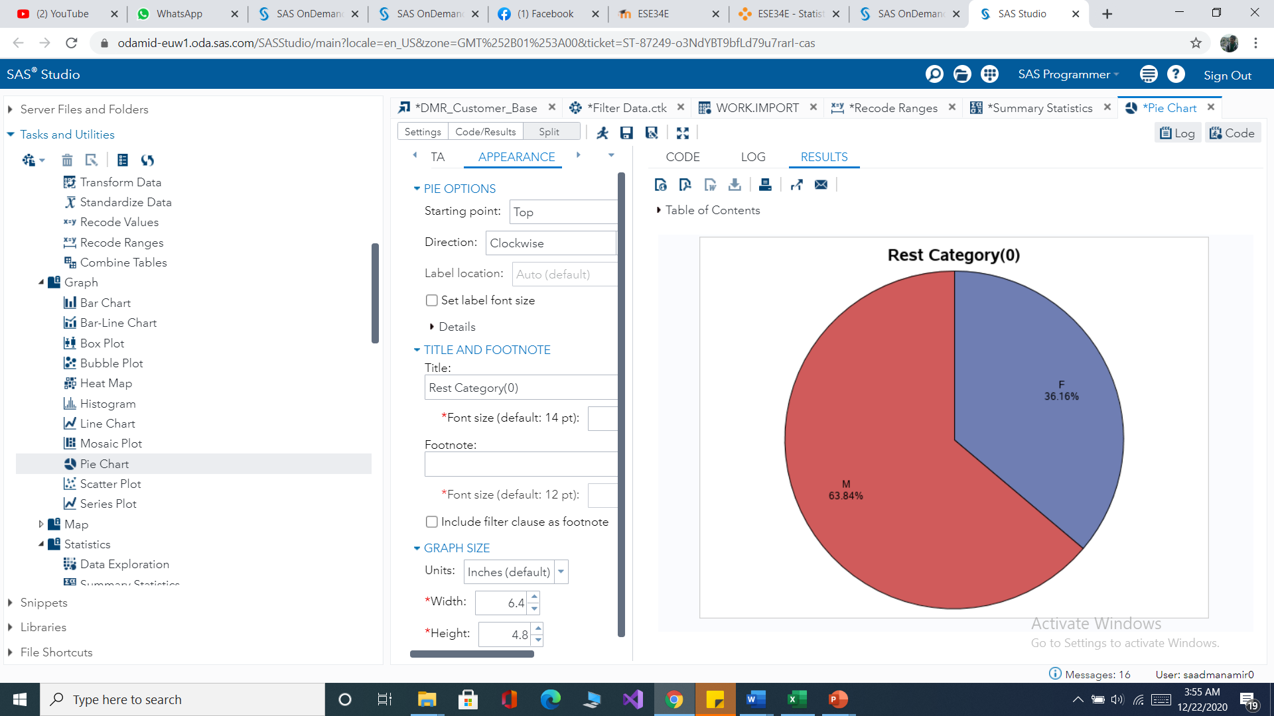

*Figure pie chart for gender and customer revenue*

**Interpretation**

* 37.54% of the population with customer revenue of 90 dollars and above are female.
* 62.46% of the population with customer revenue of 90 dollars and above are male.
* 36.16% of the population with customer revenue of below 90 dollars are female.
* 63.84% of the population with customer revenue of below 90 dollars are male.

**Examine correlation using the Correlation matrix**

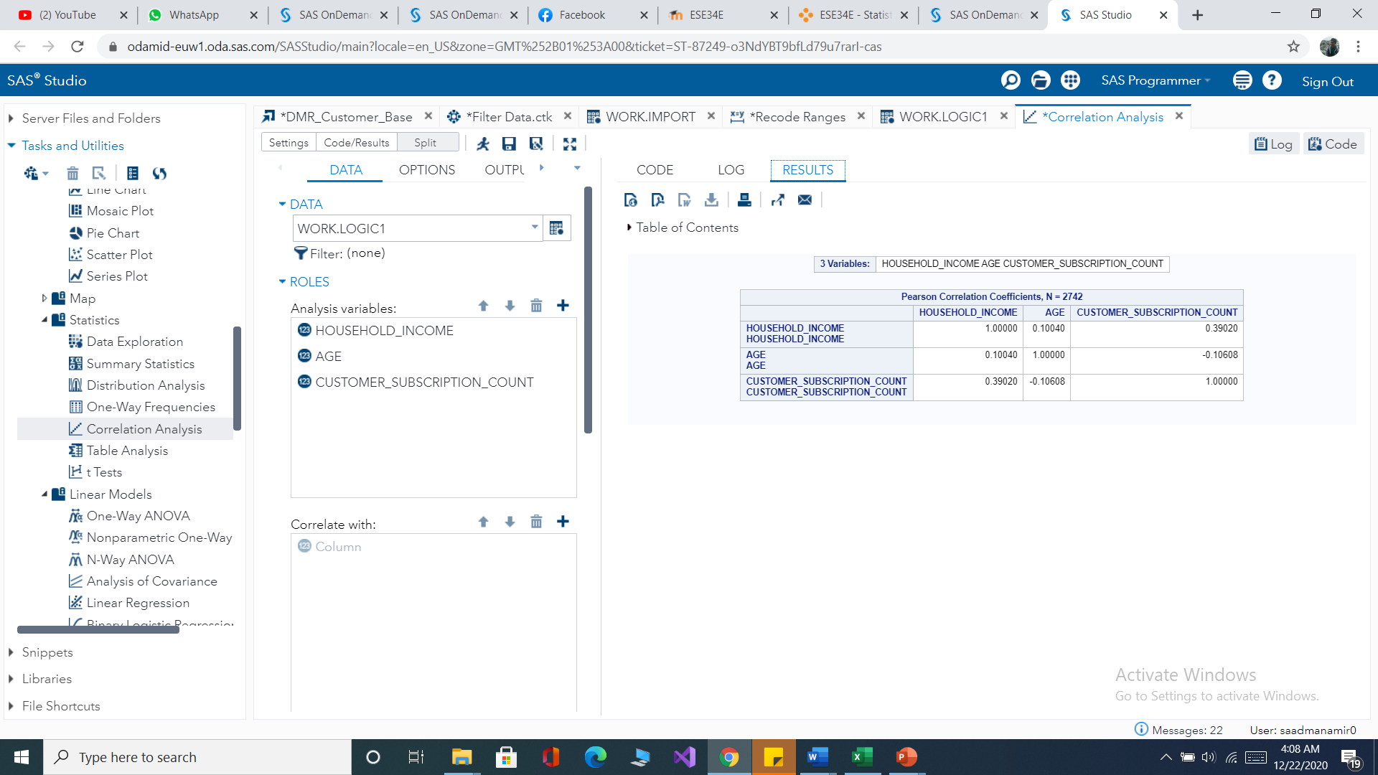

*Figure correlation matrix for classical regression*

From the above matrix, all the correlation coefficients between the explanatory variables are below 0.8 which indicates there is no problem of multicollinearity.

**Model building**

customer revenue above 90 dollars occurs which is 1.

customer revenue above 90 dollars does not occur which is 0.(customer revenue below 90 dollars occurs)

**Reference=male**

**Model for customer revenue of above 90(1)**

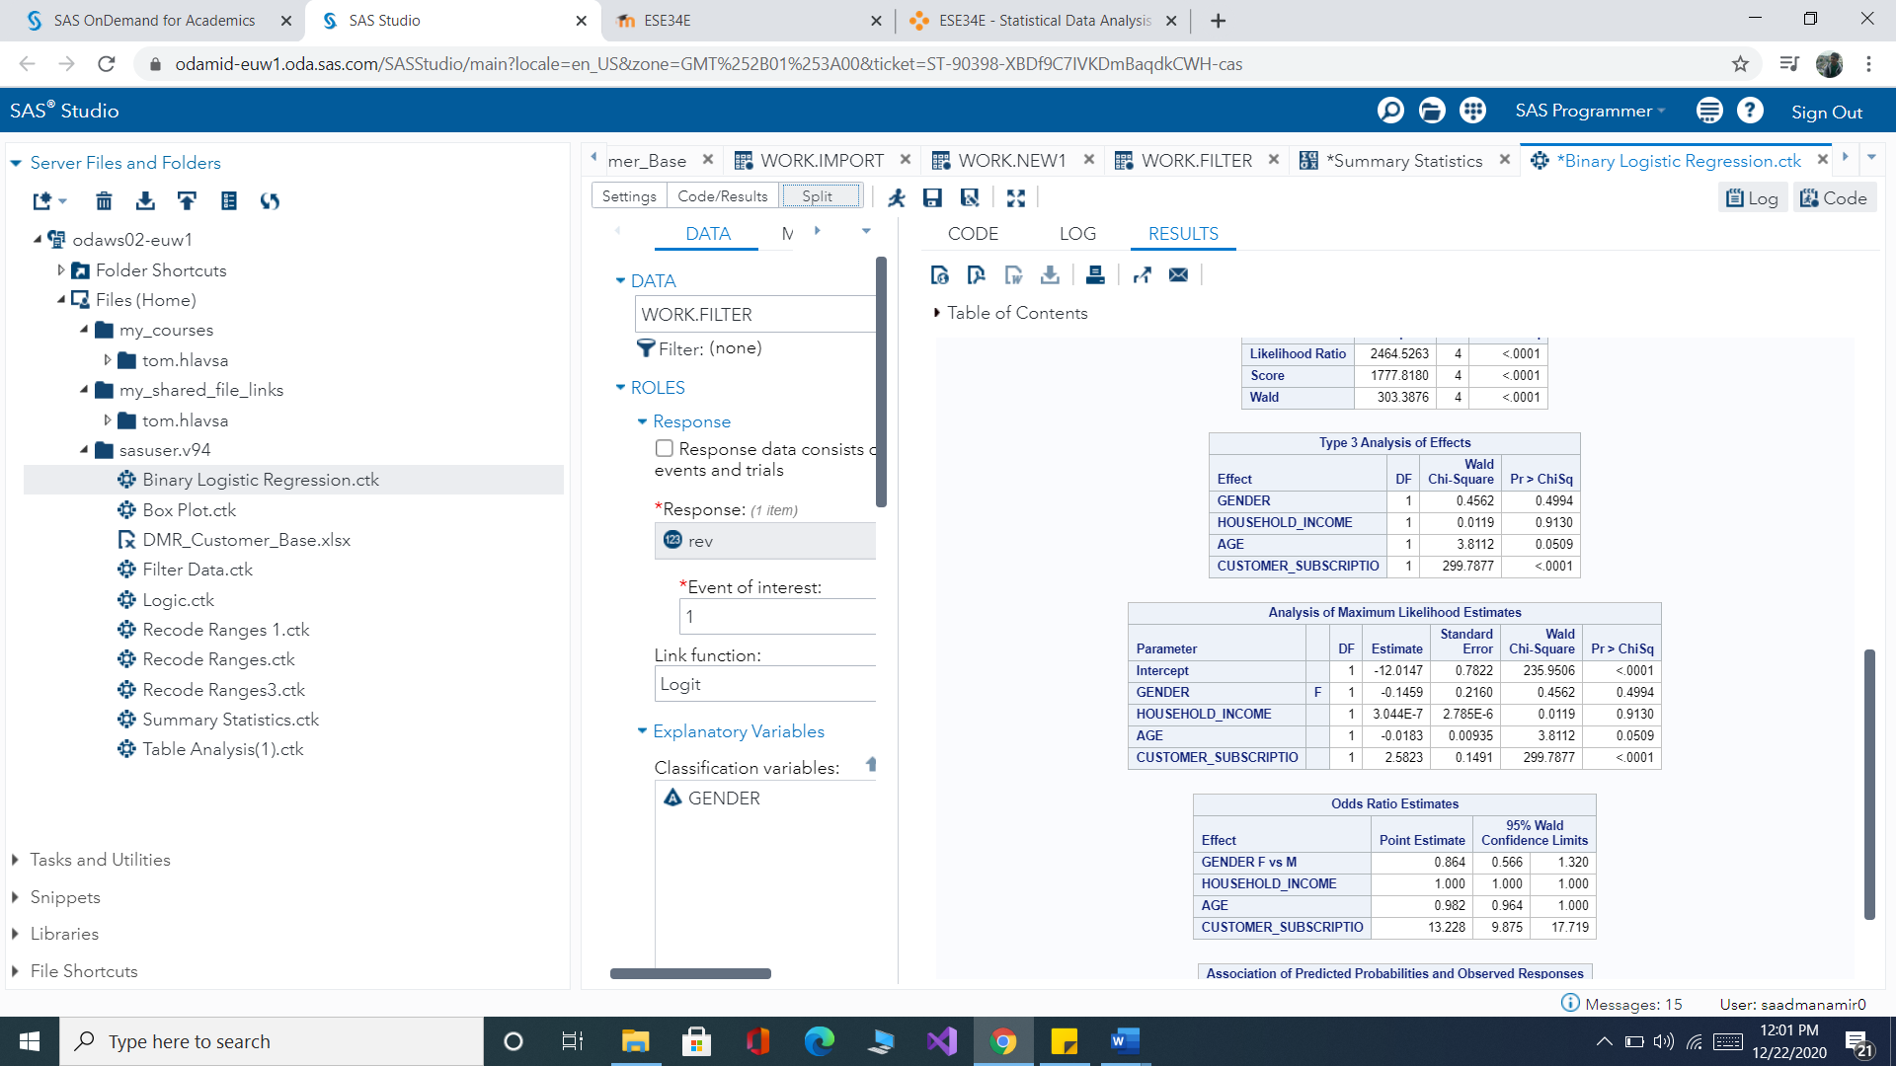

*Figure parameter estimation for model customer revenue above 90*

y→ customer revenue(1)

x1→ Age

x2→ household income

x3→ customer subscription count

x4→ gender

y=a+**ɑ**1x1+**ɑ**2x2+**ɑ**3x3+**ɑ**4x4

y=-12.0147-0.0183x1+0.00003044x2+2.5823x3-0.1459x4

**Testing (wald chi-square test)**

**whole model testing**

The significance of the whole model is examined.

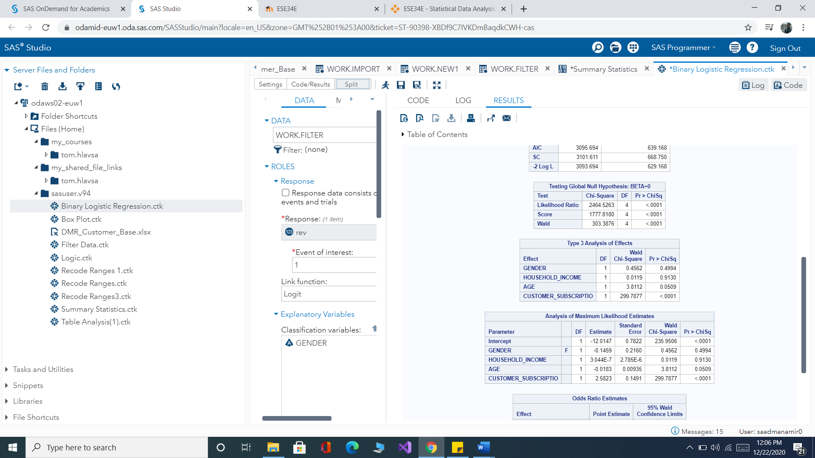

*Figure wald chi square test*

**Hypothesis**

**H0: ɑ1=ɑ2=ɑ3=ɑ4=0**

All the regression coefficients are insignificant hence the whole model is insignificant.

**H1:ɑi !=0**

At least one regression coefficient is significant hence the model is significant.

LR chi-square=2464.5263 and p-value <0.0001

We reject the null hypothesis which means the model is statistically significant. Now we need to test which parameter is significant using individual test.

**Individual test**



*Figure analysis of parameter matrix likelihood estimation*

**ɑ1(Age)**

**Hypothesis**

**H0**: **ɑ1=**0

**H1 ɑ1**!=0

chi-square=3.8112 and p-value =0.0509

The p-value is greater than 0.05 we fail to reject the null hypothesis which means Age is not a significant predictor.

**ɑ2(household income)**

**Hypothesis**

**H0**: **ɑ2=**0

**H1 ɑ2**!=0

chi-square=0.0119 and p-value =0.9130

The p-value is greater than 0.05 we fail to reject the null hypothesis which means household income does not need to be considered as a significant predictor.

**ɑ3(customer subscription count)**

**Hypothesis**

**H0**: **ɑ3=**0

**H1 ɑ3**!=0

chi-square=299.7877 and p-value <0.0001

The p-value is less than 0.005 we reject the null hypothesis which means customer subscription count needs to be considered as a significant predictor.

**ɑ4(Gender)**

**Hypothesis**

**H0**: **ɑ4=**0

**H1 ɑ4**!=0

chi-square=0.4562 and p-value =0.49

the p-value is less than 0.05 we reject the null hypothesis which means Gender is a significant predictor.

from the test, we found out predictors age and household income are insignificant indicators, so they are removed from the logistic regression model.

The new logistic regression model,

y= -12.0147-2.5823x3-0.1459x4

**odds ratio**

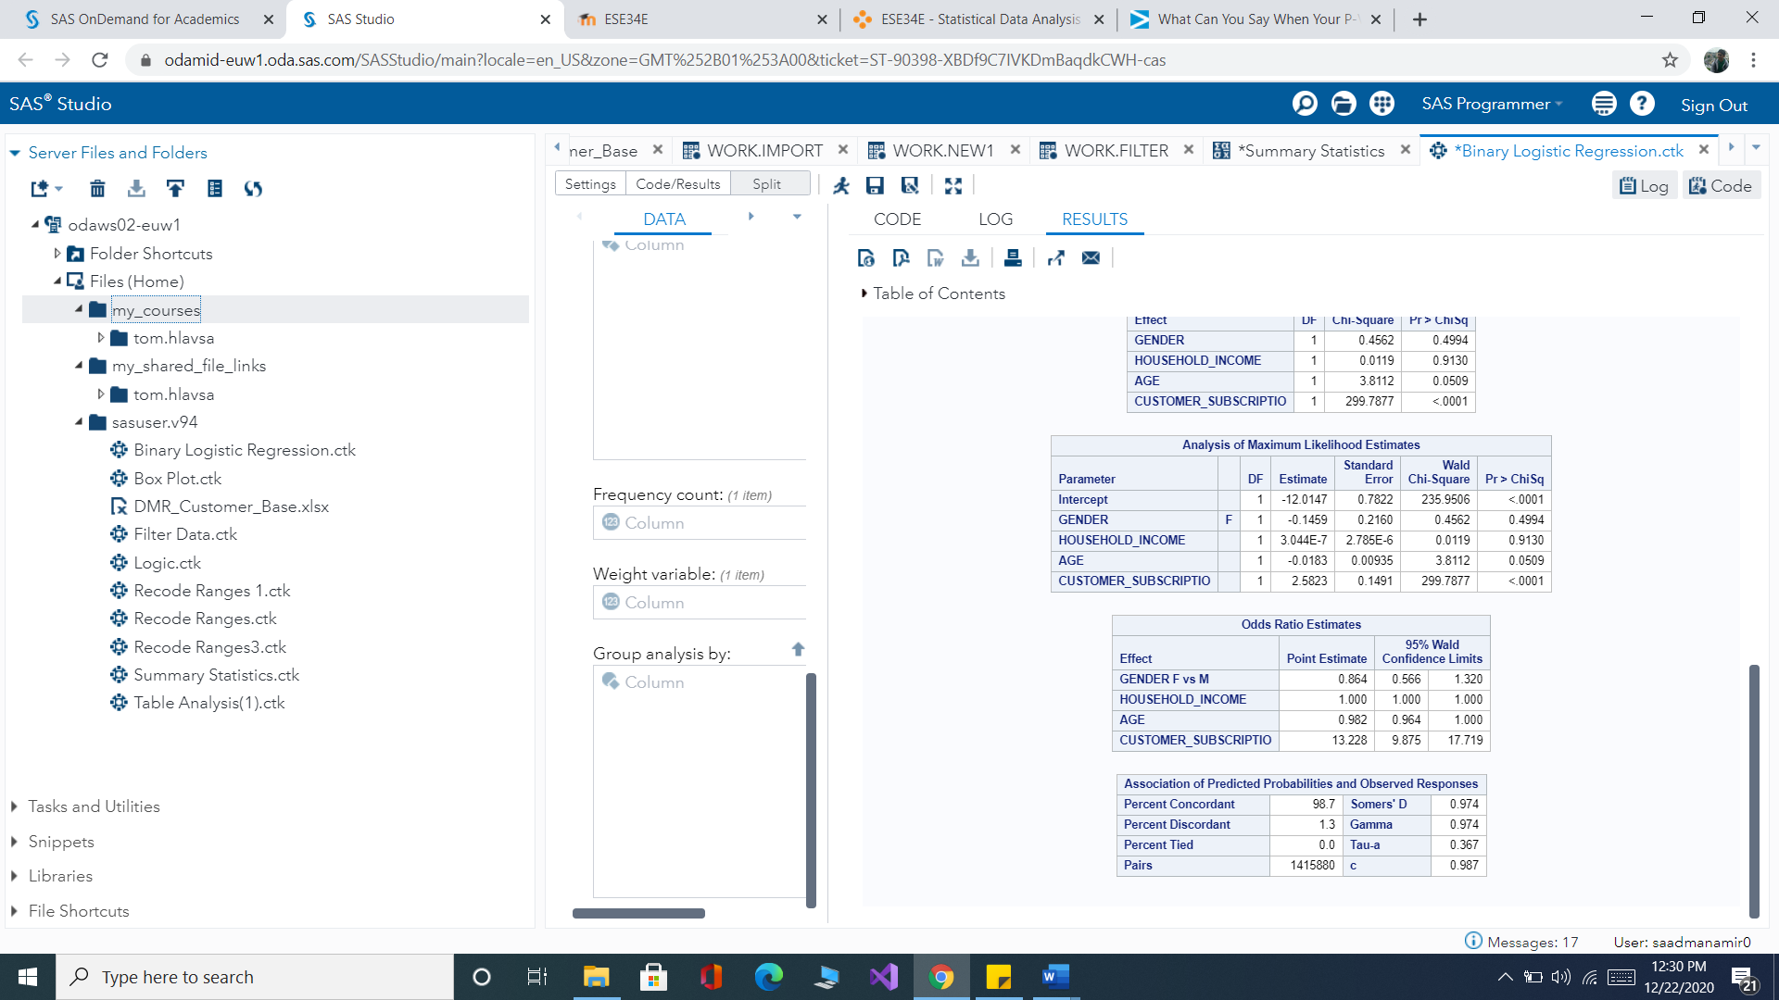

*Figure odds ratio estimation*

if Gender Changes the likelihood of the customer revenue being above 90 Changes.

if customer subscription count increases by one the likelihood of the customer revenue being above 90 increases by 13.23 times.

**Model for customer revenue of below 90**

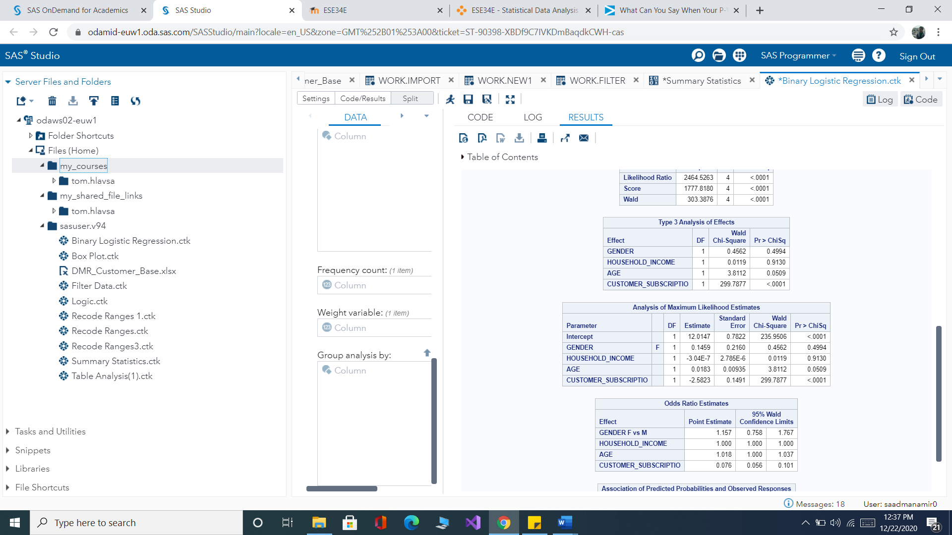

*Figure parameter estimation for customer revenue below 90*

y→ customer revenue(0)

x1→ Age

x2→ household income

x3→ customer subscription count

x4→ gender

y=12.0147+0.0183-0.00000304x2-2.5823x3+0.1459x4

**Testing(wald chi-square test)**

**Whole model testing**

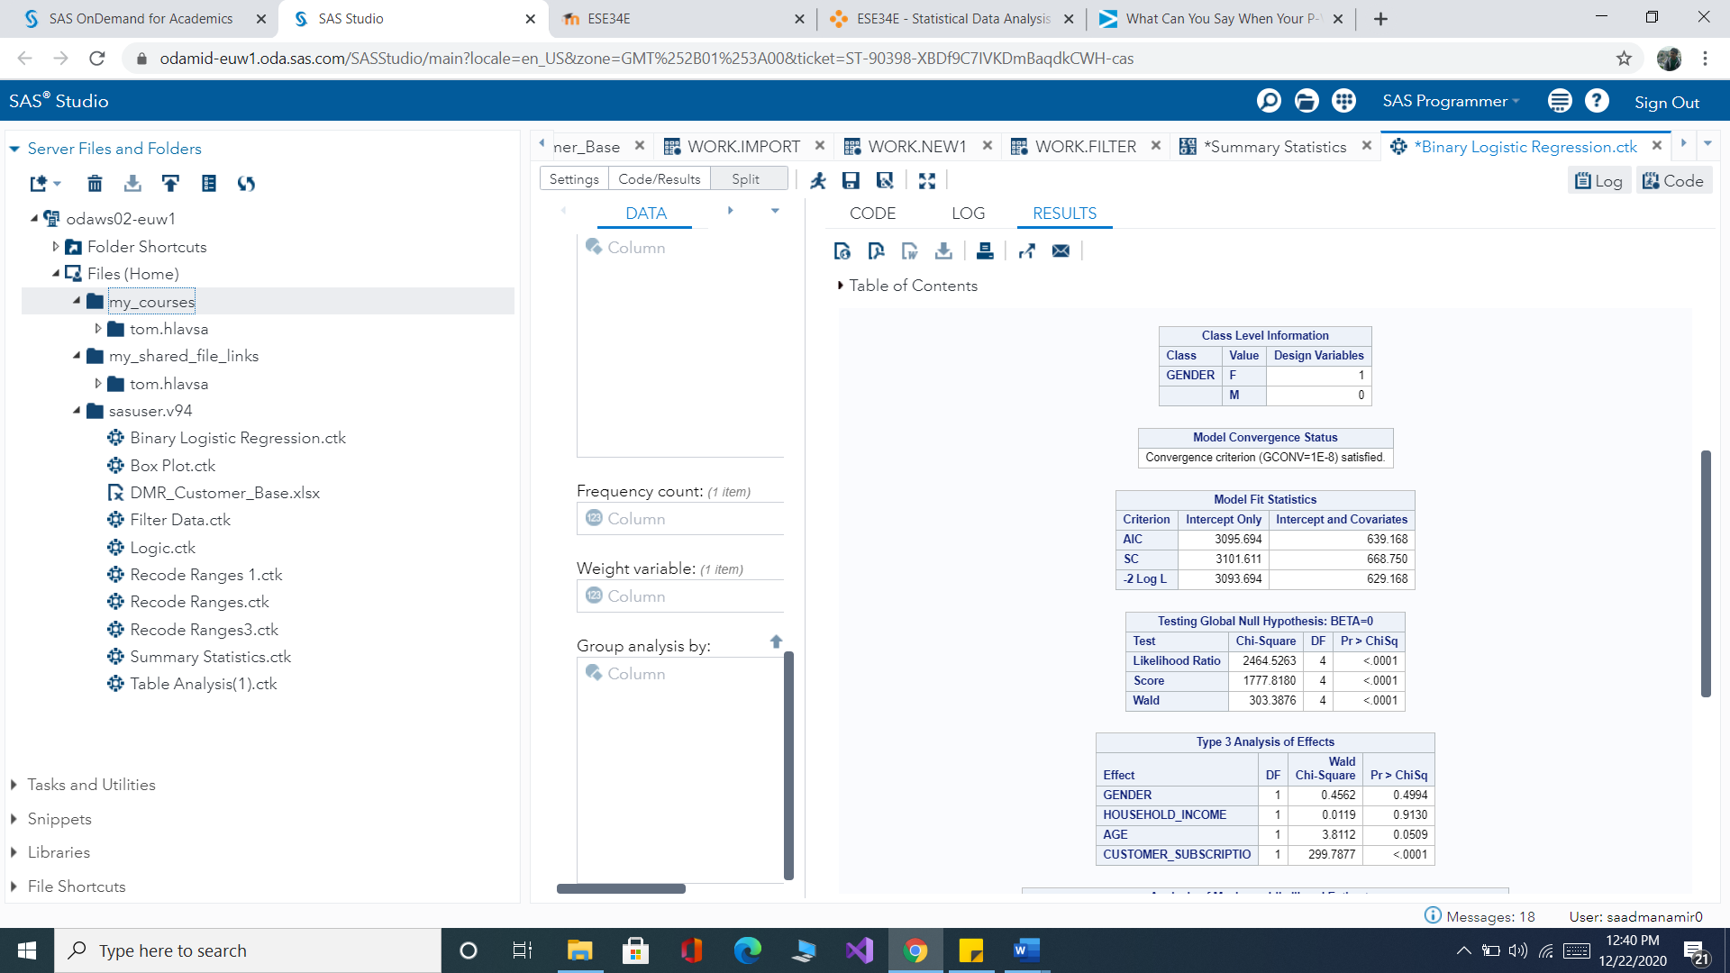

**Hypothesis**

**H0: ɑ1=ɑ2=ɑ3=ɑ4=0**

All the regression coefficients are insignificant hence the whole model is insignificant.

**H1:ɑi !=0**

At least one regression coefficient is significant hence the model is significant.

chi-square=2464.5263 and p-value <0.0001

We reject the null hypothesis which means the model is statistically significant. Now we need to test which parameter is significant using individual test.

**Individual test**



**ɑ1(Age)**

**Hypothesis**

**H0**: **ɑ1**=0

**H1 ɑ1**!=0

chi-square=3.8112 and p-value =0.0509

The p-value is greater than 0.05 we fail to reject the null hypothesis which means Age is not a significant predictor.

**ɑ2(household income)**

**Hypothesis**

**H0**: **ɑ2**=0

**H1 ɑ2**=0

chi-square=0.0119 and p-value =0.9130

The p-value is greater than 0.05 we fail to reject the null hypothesis which means household income does not need to be considered as a significant predictor.

**ɑ3(customer subscription count)**

**Hypothesis**

**H0**: **ɑ3**=0

**H1 ɑ**!=0

chi-square=299.7877 and p-value <0.0001

The p-value is less than 0.005 we reject the null hypothesis which means customer subscription count needs to be considered as a significant predictor.

**ɑ4(Gender)**

**Hypothesis**

**H0**: **ɑ4**=0

**H1 ɑ4**!=0

chi-square=0.4562 and p-value =0.4994

the p-value is less than 0.05 we fail to reject the null hypothesis which means age is a significant predictor.

from the test, we found out predictors Gender and Customer Subscription are significant indicators.

The new logistic regression model,

y=-7.1933+0.00000418x2+1.33x3

**Odds ratio**

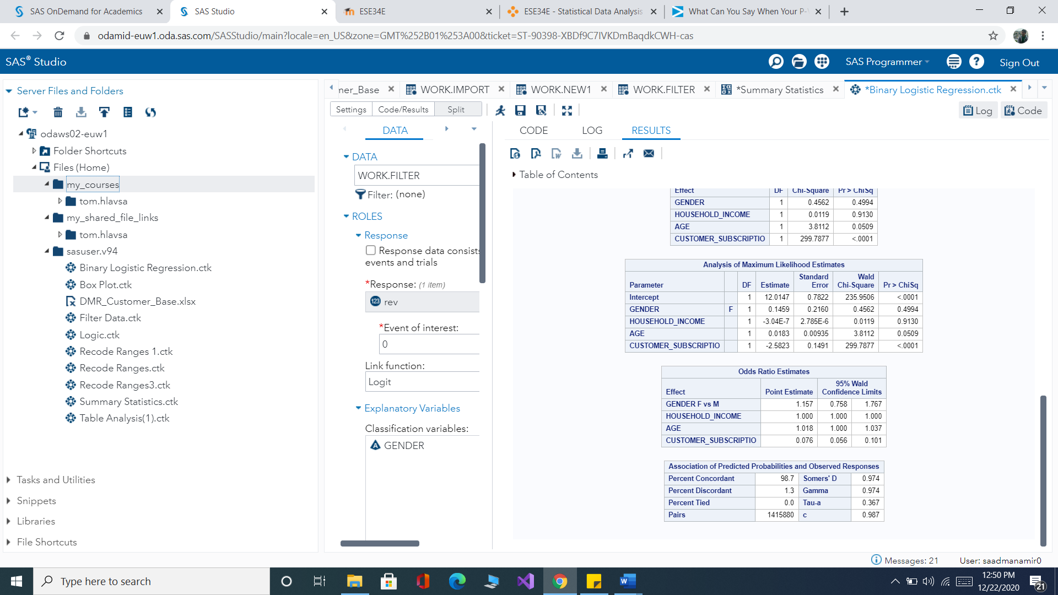

*Figure odds ratio estimation of parameter*

if Gender Changes the likelihood of the customer revenue below 90 Changes.

if customer subscription count increases by one the likelihood of the customer revenue being below 90 increased by 0.076 times.

**Coefficient of determination**

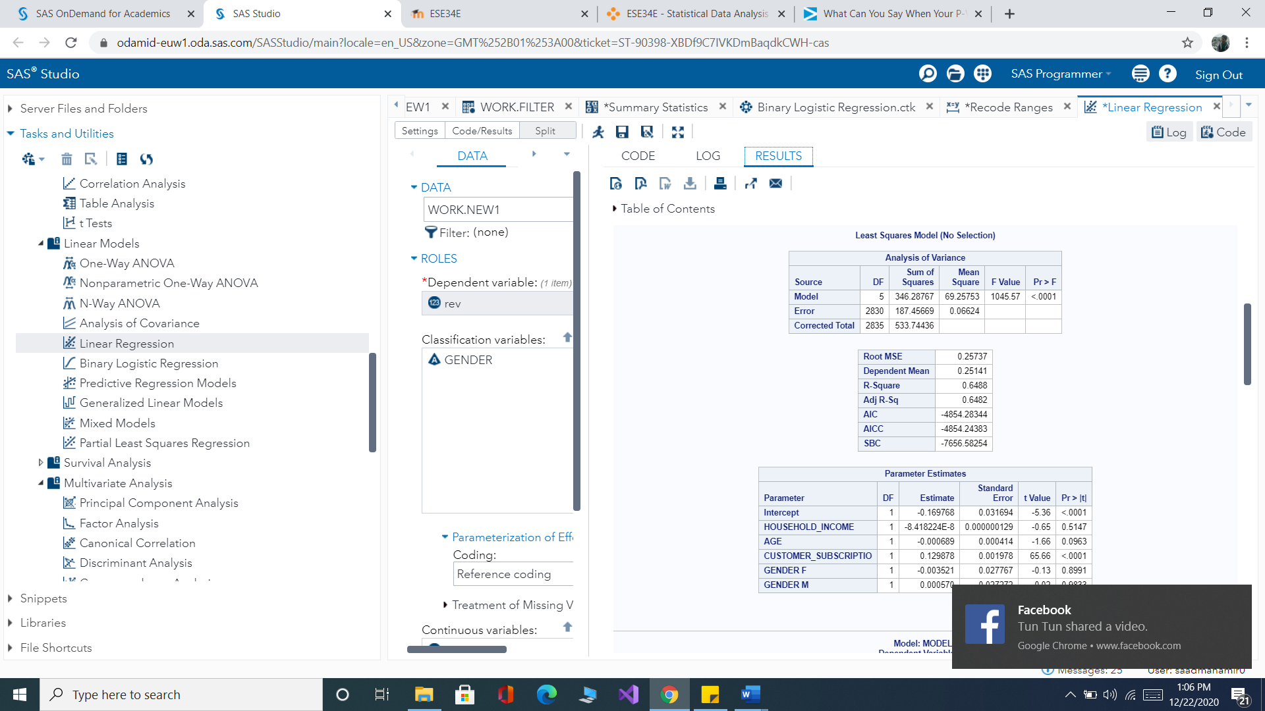

R square value is 0.6488 which implies 64 percent of the variation of customer revenue is explained by the variation of the explanatory variables.

## Conclusion

Customers Whether male or Female different amounts have an equal chance of having revenue of above and below 90 dollars.

Customers with a high subscription are more likely to have a higher chance of having customer revenue of 90 dollars increases.